

**Enhancing Airport Safety Using Crowd Monitoring and Social Distance Analysis**

**Group Design Project (GDP) – Group 5**

Applied Artificial Intelligence (AAI) MSc.

Cranfield University

Benjamin David Fraser

Brendan Copp

Gurpreet Singh

Orhan Keyvan

Tongfei Bian

Valentin Sonntag

***Table of Contents***

*List of tables and figures* iv

1. Introduction 1

1.1 Problem statement, aims and overview 1

1.2 Project Management and Planning Strategies 1

1.3 Prior Works 2

1.3.1 Inter-person distance estimation 3

1.3.2 Pose and mask detection 3

1.3.3 Crowd Monitoring, control and analysis 4

2. System Technical Overview 4

2.1 Description and Introduction 4

2.2 Technical System Requirements 5

2.3 System Architecture (Hardware and Software) 6

3. System Detailed Design 6

3.1 Phase 1: Multi-Person Pose Estimation 6

3.2 Phase 2: System Downstream Tasks 9

3.3 Phase 3: Integration of results into a dashboard application 16

4. Experimentation and Modelling 20

4.1 Experimentation Introduction 20

4.2 Multi-Pose Crowd Estimation Methodology 20

4.3 Downstream Modelling Methodologies 21

4.3 Testing and Validation Strategies 28

4.4 Final System Demonstration and Results 28

4.5 System Results Discussions 29

5. Final Project Discussions 29

5.1 Summary of project achievements 29

5.2 Real-World Deployment Considerations 30

5.3 Ethical Considerations 30

5.4 Project Management and Team Reflections 31

5.5 Future Work, Improvements and Potential Applications 31

6. Conclusions 32

References 33

*Annexes* 35

Annex A: Project Gantt Chart 1

Annex B: Project Risk Register 1

Annex C: Integrated System Test Plan 1

# *List of tables and figures*

**Figures**

**Figure 1.** Team organisational chart with lead roles and key tasks for each team member. 2

**Figure 2.** Technical modelling three-phase pipeline. 5

**Figure 3.** Comparisons of AlphaPose and OpenPose on custom crowd dataset examples. 7

**Figure 4.** Summary of AlphaPose, taken from Fang et al (2017). 8

**Figure 5.** Summary of CrowdPose, taken from Li et al (2019). 8

**Figure 6.** Summary of the system downstream models. 9

**Figure 7.** Examples of person counting using the results from the AlphaPose modelling pipeline. 10

**Figure 8.** Overview of the distance estimation pipeline. 11

**Figure 9.** Visualisation of the camera focal plane projection (3D view and image view). 12

**Figure 10.** Examples of five classes. 13

**Figure 11.** Overview of the pose behaviour classification module pipeline. 14

**Figure 12.** Overview of the mask classification module pipeline. 15

**Figure 13.** Overview of the mask classification module pipeline. 15

**Figure 14.** Effusion of a cough cloud in standing position, un-masked at (a) 1 seconds, (b) 5 seconds and sitting position at (c) 1 seconds, (d) 30 seconds. 16

**Figure 15.** Cough particle spread comparison between standing and sitting positions. MAX represents maximum particle travel distance. 17

**Figure 16.** Example of the risk density heatmap on the top-down perspective of a scene. 18

**Figure 17.** Example of projecting an averaged heatmap over all timesteps on original scene. 18

**Figure 18.** The dashboard application displaying the CCTV footage, the heatmap prediction and various statistics. 19

**Figure 19.** Dashboard displaying the scene at (a) 1 seconds, averaged risk-regions at (b) 5 seconds, (c) 10 seconds and (d) all timesteps. 19

**Figure 20.** The dashboard application displaying statistics about the scene. 20

**Figure 21.** Pose-estimation pipeline used to process video inputs. 21

**Figure 22.** Overview of the parameters’ estimation 23

**Figure 23.** Structure of pose behaviour classification model 25

**Figure 24.** Accuracy and loss during training process. 25

**Figure 25.** Confusion matrix of pose behaviour classification model. 25

**Figure 26.** Summary of the mask classification modelling process. 26

**Figure 27.** Summary of the mask classification modelling process. 27

**Figure 28.** BiT mask classifier final results on the held-out test set. 27

**Figure 29.** BiT mask classifier final confusion matrix on the held-out test set. 28

**Tables**

**Table 1.** System and User requirements developed for the proposed system. 6

# 1. Introduction

## 1.1 Problem statement, aims and overview

**[Initial work done by Ben – to be extended & formalised by Gurpreet and Brendan]**

Recent years have emphasised the importance that safe social measures and compliance can have throughout public locations such as airports, especially during pandemic outbreaks such as COVID-19. Despite huge progressions in vaccination rollouts and the success in tackling the recent pandemic, the World Health Organisation (WHO) still recommends social distancing measures are adopted throughout public and crowded locations to help protect the population and maximise safety. This includes minimising unnecessary presence in locations that are closed, crowded or involve regular close-contact. Furthermore, it recommends correct usage of masks to further increase safety. [consider getting references for this information, along with more as required].

Airports have huge influxes of passenger flows every single day, and similarly to many other crowded locations and organisations, they have an obligation to ensure public safety and ensure adequate measures are implemented to mitigate risks during these times. These locations involve frequent close contact, crowds and closed spaces, all of which increase the likelihood of airborne transmission of viruses.

In this work, an integrated vision-based system is proposed to provide multi-functional crowd monitoring and analysis throughout airport locations. The outputs of the system are intended to benefit airport management staff and passengers alike, through providing crowd-based and intelligence. The core focus of the project is on social distancing analysis, however the system principles are extendable to many other applications, especially those involving public or crowded locations.

The overall project aim is to provide airports with the ability to exploit daily crowd-based data to enhance their processes and benefit passenger safety, along with being able to demonstrate that their public services and spaces are being managed safely, particularly during future pandemics or outbreaks.

Novel contributions of this work include the following:

1. Integrating crowd-pose features to perform social distance analysis and crowd monitoring.
2. Crowd distance estimation and categorisation using homography techniques without the need of any sort of camera calibration and physical referencing to be carried out.
3. Efficient item classification (masks in this work) of persons using pose-feature extracted regions and image classification.
4. Development of a combined social compliance metric, which can be used to gauge safety of crowds during pandemics or for other more general crowd analytics.

## 1.2 Project Management and Planning Strategies

To aid project planning, the scope, including the stakeholder requirements and how the delivered product will work, was defined. This established the project boundaries and helped create a breakdown of the deliverables required to achieve the project. These deliverables were subsequently formed into a list of main project activities and sequenced actions required. By estimating task durations and incorporating this into the formal project plan, a Gantt chart was produced, as provided in Annex A.

A waterfall-based project approach with sequential tasking was used to progress the overall project, from inception up to the delivery of the final presentation and report. However, the data science design naturally required an iterative and continually improving approach, and so multiple agile sprint phases were used to manage this. Two sprints were completed, each of which comprised a focussed effort to accomplish a tangible set of milestones, with focus on the coding and software design of the system models and dashboard components. These phases are annotated within the Gantt chart.

In order to manage the vast range of project tasks and system components, each team member was allocated a key role and area of responsibility. Throughout the project, each member was accountable for managing their associated area, ensuring completion of area-specific tasks, and raising any issues as part of the routine project review team meetings. These lead roles and key tasks for each member are summarised in Figure 1.

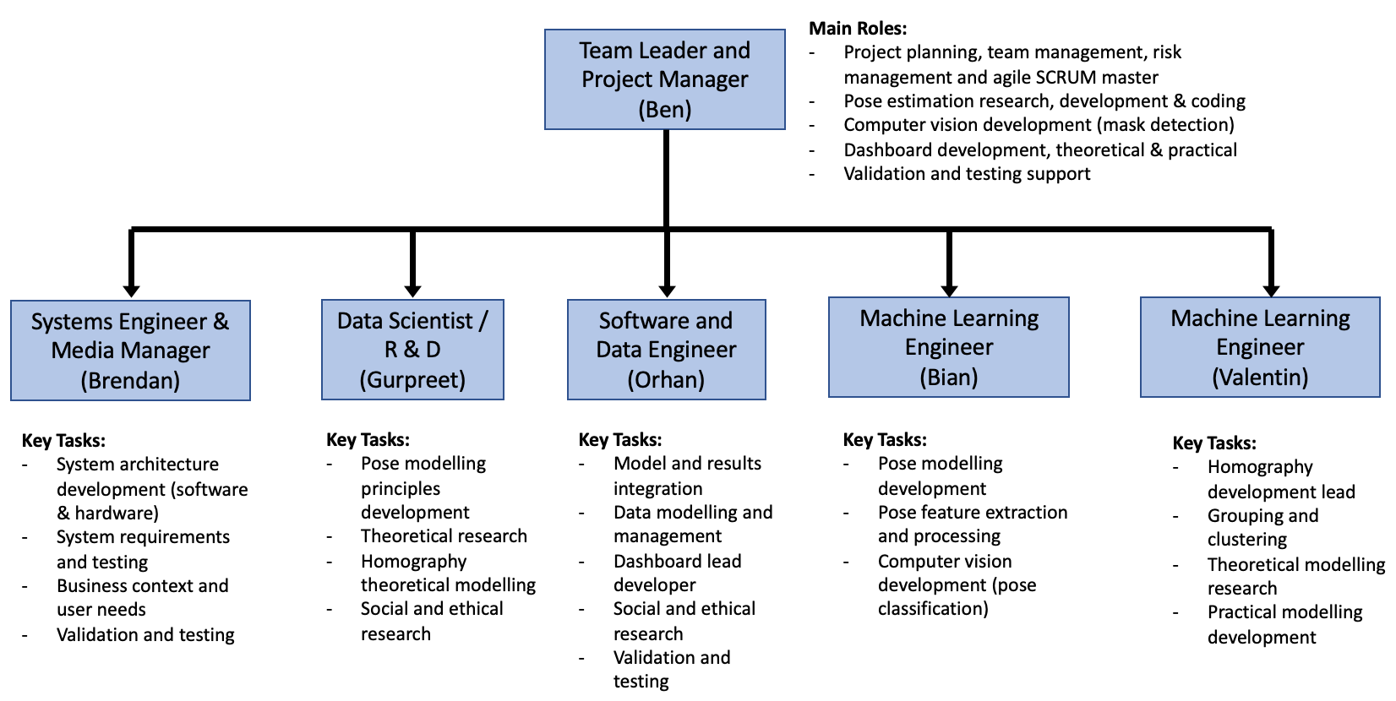

**Figure 1.** Team organisational chart with lead roles and key tasks for each team member.

For code version control and collaboration git was used, in conjunction with a repository on GitHub for team code collaboration (<https://github.com/biantongfei/GDP_group5>). This helped efficiently manage code development and allowed changes to be worked on simultaneously by different team members. It also ensured all team members were kept up to date on the latest changes of code with minimal effort. In order to manage the code-specific tasks required by each team member, a KANBAN task management and progression system was also adopted, which helped capture where each member of the team was currently and what was still outstanding.

For risk management, a risk register was developed and maintained throughout the entirety of the project. The main risks were identified, reviewed, and allocated to suitable team members, who then assumed responsibility for assessing and mitigating their risks to manageable levels. For this process, each output consequence was analysed in terms of former likelihood, impact and overall priority, which represented the former risk before any mitigating actions or barriers were introduced. Mitigating actions were then introduced, after which each risk was re-analysed in terms of residual likelihood, impact and overall priority. The end result was a set of acceptable project risks with appropriate contingency plans, as documented in the risk register at Annex B.

## 1.3 Prior Works

**[Section developer – Gurpreet]**

[Literature review / discussion of prior works in the chosen context. This needs to cover standard pose estimation techniques, along with developing this into multi-pose estimation (multiple people and crowds).

It should also expand into works that have specifically aimed to tackle the crowd monitoring and social distancing problem, and how they did this.

In addition, we should cover some of the works on mask object detection, 2D scene distance estimation, and clustering of social groups in scenes.

This will then lead into how our work expands on some of these works, and develops an integrated system to manage crowds, which can be applied to the problem of social distancing analysis.]

Since the outburst of COVID-19 pandemic, there has been several numbers of measures taken by the various agencies across the globe to ensure social distancing in public places as this has been established as one of the most effective ways to contain the spread of the virus. Out of all these techniques, many efforts have been put to develop methods enabling vision based social distancing using artificial intelligence. Discussed below are the summaries of few such endeavours and the basic methods and techniques used by them.

## 1.3.1 Inter-person distance estimation

In the paper [1], the final prototype developed is an integrated embedded system that detects social distance with the camera using the Faster R-CNN model. The software developed using the ‘‘Nvidia Jetson Nano’’

development kit and Raspberry Pi camera module calculates all necessary actions, detects social distance violations, makes audible and light warnings, and reports the results to the server. For the social distance estimation, the inclined camera view is transformed into the bird’s eye view on a predefined user provided frame using open CV library.

The advantage of the system is its accuracy as it calculates inter-person distance from bird’s eye view but the set up needs to be referenced once by the user after carrying out ground measurements. However, accuracy on people in different poses like sitting and lying down is doubtful. The second paper [2] has the similar approach but with certain additional features like pose based human recognition using OpenPose which is considered better than object detection (object detection sometimes yields incomplete and oversized bounding boxes which does not offer rich information). One more work [3] mentions the methods which are designed on the similar lines as the last one but with an additional feature of crowd density analysis.

Paper [4] and [5] have works that mention the techniques to work out the approximate homography matrices automatically to a reasonable accuracy. Automated homography enables the designed systems to be workable at any preinstalled cameras without the need of any sort of calibration or ground plane measurements to be carried out. The method in [4] assumes certain intrinsic conditions for the camera positions to be constant and thereby treating all detected persons to be of an approximately equal torso length (Torso length recovered in pixels from pose extraction) calculates the localised homographic matrix for each person. Using this matrix, a localised safe zone ellipse is drawn around each person in the frame. Paper [5] mentions of a technique which relies on the use of least squares approximation method to work out the camera parameters by assuming every person to be of approximately equal height. Paper [6] uses a relatively simple technique for inter-person distance measurement. Bounding box centroid width between any two persons being considered is averaged and compared against the standard width of an average human body and thereby used as a scale to convert the inter-person pixel distance into the ground plane distance. However, this technique is may not be very accurate for the persons who are either very close or far from the camera.

## 1.3.2 Pose and mask detection

Paper [1], [3] and [5] have used object detection techniques like YOLO and Faster R-CNN for detecting and drawing bounding boxes around the persons in a scene. Whereas other works like [2], [4], [7] and [13] have used pose-based person detection. As per available literature on vision based social distancing methods, it emerges out that pose based person detection has a clear edge over the object detection techniques as the information extracted out of pose features is quite rich and helps in homographic calculations thereby producing better results as compared to the information extracted from the bounding boxes. The papers using pose detection have stated success in social distancing analysis for the persons in various poses like sitting, lying and riding whereas the same thing is missing in the object-based person detection techniques.

Most of the papers have either focussed on social distancing (like [1],[2],[3],[4] and [5]) or face mask detection ([11],[12] and [13]). However, there are very limited ones which have tacked both issues ([8] and [9]). The work in [8] used have used four different models at various stages i.e., YOLO for person detection, DBSCAN for social distancing, DSFD RetinaNetMobileNetV1for face detection and ResNet50 Xception MobileNetV2 for mask detection whereas paper [9] has used YOLO for the mask detection. Similarly, papers [11] and [12] have gone for single stage object detection methods whereas paper [10] have used two stage object detector. However, none of the works have used any pose derived method for mask detection.

## 1.3.3 Crowd Monitoring, control and analysis

Based on the vision based social distancing detection methods in various papers, various crowd control measures have been recommended to be used. The papers []Various crowd monitoring and control techniques have been discussed in the papers

……..……………

[Part 1 should be ~1500-2000 words total]

# 2. System Technical Overview

**[Initial content developed by Ben, further as required by Brendan]**

## 2.1 Description and Introduction

The system consists of an integrated platform to analyse and monitor crowds in public locations using video surveillance feeds. The focus is specifically for smart airports, but the basic framework is adaptable to any public context where analysing and monitoring crowd characteristics is useful.

The overall AI framework can be broken down into three distinct phases (Figure 2):

1. Input video processing and extraction of multi-person pose features using pose estimation.
2. Multi-purpose downstream-modelling of pose features.
3. Integration of results into a dashboard front-end application.

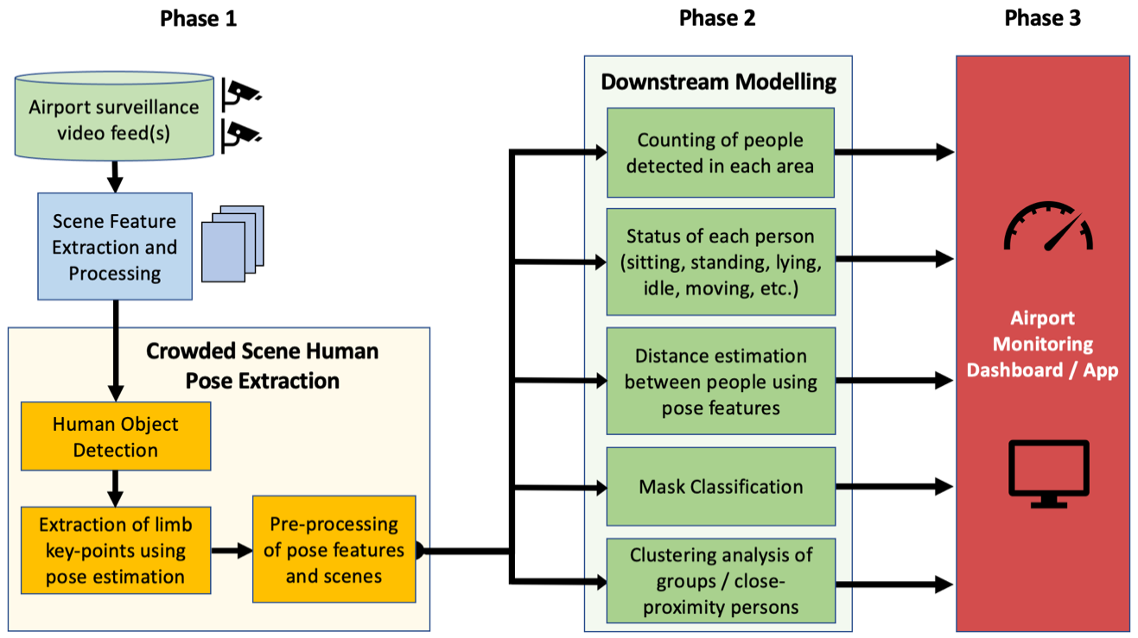

**Figure 2.** Technical modelling three-phase pipeline.

Each of these phases will be covered in detail, including the specific design methodologies in Section 3 and the modelling (code) specific activities in Section 4.

The final output of the system is designed to provide airport management with a set of tools and data sources that can be used to better manage and understand crowded regions throughout a large range of areas. This includes a risk density-heatmap visualisation tool that highlights the most risk-prone regions in surveillance video feeds in real-time or over averaged over a chosen period of time. The risk is determined in terms of social distancing measures, including a combination of inter-person distance proximity, mask usage, and current behaviour, all of which are determined using the pose estimation-based framework.

The system also provides summary visualisations for each airport area, including person counts, mask usage, distancing compliance (relative to a chosen distance threshold), group clusters and sizes, and current predicted behaviour (standing, walking, sitting, lying or other). This can help airports spot trends across different areas they manage, which can be used to make improvements in terms of passenger social safety and general wellbeing throughout the airport. Furthermore, these features could provide added commercial benefits, such as identifying the most popular regions in the airport at certain times during the day. Conversely, it could be used to identify areas of lower usage, which could help signpost passengers to areas where they are more likely to obtain seating and peace whilst waiting.

## 2.2 Technical System Requirements

To lead development and progression of the proposed system throughout the project, it was important to develop and clearly define the system and user requirements. These were generated early in the project, and are given in Table 1 below.

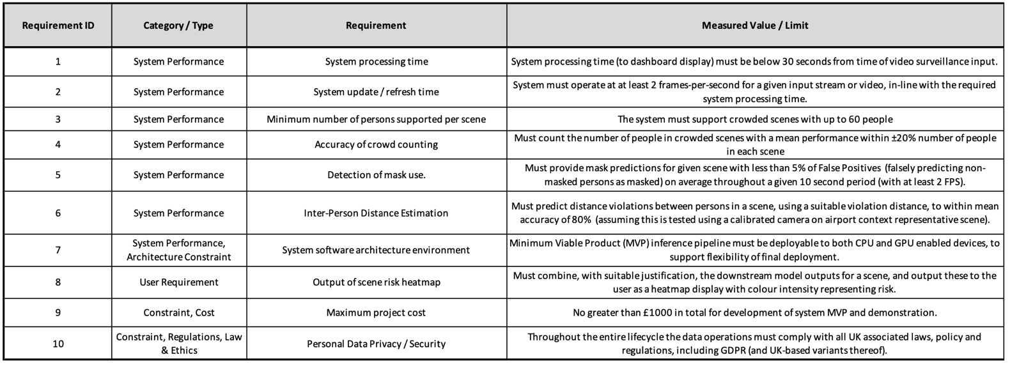

**Table 1.** System and User requirements developed for the proposed system.

These core requirements were used to inform the development of our integrated test and evaluation plan, which consisted of a set of final tests and criteria that provided assurance the system meets these original requirements. This will be discussed layer during testing and validation.

[Part 2- above this point is 428 words]

## 2.3 System Architecture (Hardware and Software)

**[Section developer – Brendan]**

[Part 2 should be no more than ~500-1000 words total]

# 3. System Detailed Design

## 3.1 Phase 1: Multi-Person Pose Estimation

**3.1.1 Pose Estimation Introduction**

Modern AI-based person detection is often performed using either object detection or pose estimation. The former is more generic and usually consists of detecting one or more persons in a scene, followed by fitting a bounding box to each. This is effective for basic detection but does not provide any further information on the specific person. Conversely, pose estimation is more refined and involves detecting all key body parts for each person in a scene, which provides context into the body positions, orientations and actions being performed. In addition, pose estimation techniques can work well for detecting obscured or partially visible people, which can be problematic for basic bounding box object detectors.

Pose estimation techniques take a processed image as the input and output estimated localisations for all key body-points detected in the scene. Many well-known and popular models exist, which are generally broken down into either bottom-up or top-down approaches.

Bottom-up approaches first detect all potential body-parts in the scene, followed by associating each part to distinct individuals. This is also known as a part-based approach. The challenge with this approach is that association of parts becomes difficult for crowded scenes. On the other hand, top-down approaches represent a two-step process that uses a person detector first (usually object detection), followed by applying more refined single-person pose estimation on each bounding-box region (Fang et al., 2017). This results in a set of pose features for each person detected. The performance of these models depends highly on the effectiveness of the initial person detector.

Single-person and multi-person pose estimation techniques have improved in recent years, with existing pre-trained models working reliably on scenes with small numbers of people. However, a challenge remains for applying multi-pose estimation accurately and reliably to dense and crowded scenes.

**3.1.2 Pose Estimation Model Comparison and Selection**

Two main open-source variants for multi-pose estimation were researched and evaluated in terms of their suitability for the chosen context of airport crowd monitoring. This included OpenPose, a popular bottom-up model, and AlphaPose, a top-down based approach. To help compare the effectiveness of these algorithms, experiments were performed which compared their performance in extracting pose features from complex and crowded scenes. A custom camera surveillance dataset containing crowded scenes was developed to perform this, which made use of existing open-source datasets [reference to datasets used here]. These scenes were chosen based on their similarity and relevance to the project context of airport surveillance camera feeds. Some comparisons made are shown in Figure 3.

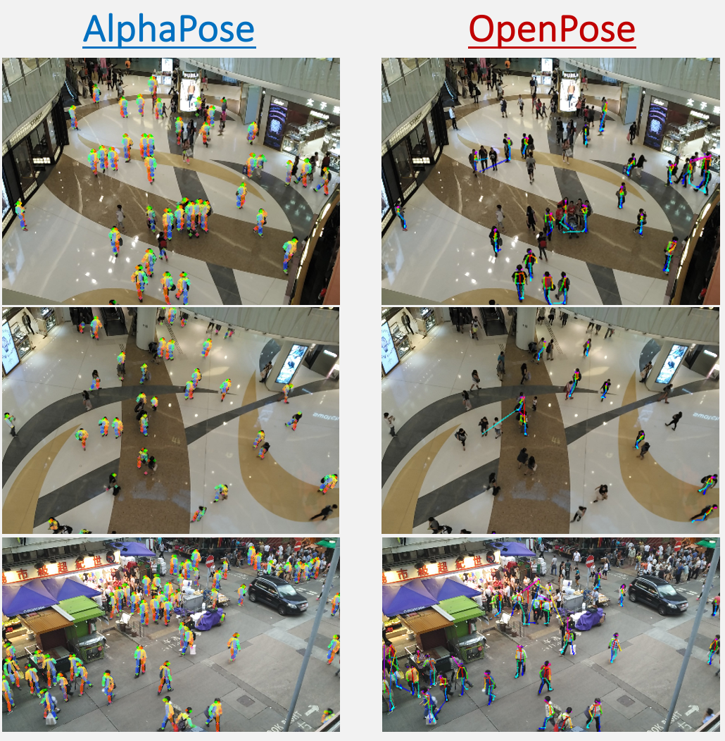

**Figure 3.** Comparisons of AlphaPose and OpenPose on custom crowd dataset examples.

Based on the experiments, AlphaPose was superior for extracting pose features from crowded scenes. It performed remarkable well, given the challenging viewpoints of the images and the large numbers of people. Conversely, OpenPose struggled with dense regions and would often erroneously predict a group of people as an individual (Figure 3 – right side). This poor performance would not suffice for the system, and therefore AlphaPose was evaluated most suitable.

**3.1.3 AlphaPose Technical Description**

The original AlphaPose model works by taking in human bounding-boxes from an object detector (YOLOv3 in this case), which are fed into symmetric Spatial Transformer Network (STN) and Single Person Pose Estimator (SPPE) modules. The STN acts to select dominant human proposals from the inputs, which are then processed by the SPPE to obtain pose features. These pose features are then remapped to the original images using a Spatial De-Transformer Network (SDTN). A parallel SPPE branch is also included during training to help the STN to extract dominant single person proposals. This process is summarised in Figure 3, taken from Fang et al (2017).

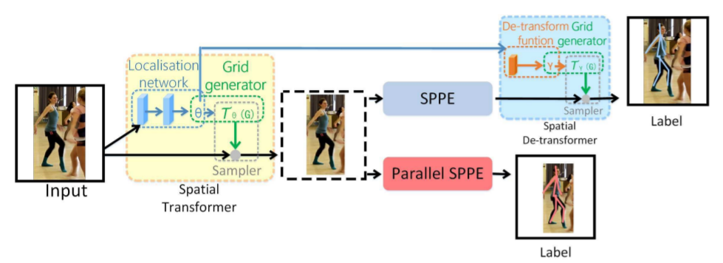

**Figure 4.** Summary of AlphaPose, taken from Fang et al (2017).

A problem with this architecture is the degraded performance in complex and crowded scenes. These issues were improved upon significantly as part of the architectural improvements proposed by CrowdPose (Li et al., 2019). This approach adopts the same top-down approach used by AlphaPose, but applies more SPPE units through the introduction of a Joint-Candidate (JC) SPPE module. Each SPPE within the JC SPPE module locates the candidate key-points for each human proposal region. The proposed key-points from each SPPE may contain unwanted joints from other people in the proposed region (like crowded scenes). The results from all SPPE units are fed into a global association network, which finds the best joint association results for each person using their proposed global maximum joints association algorithm. An overview of this process is given in Figure 5, taken from Li et al (2019).

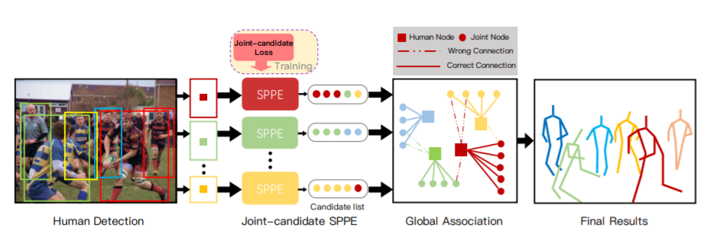

**Figure 5.** Summary of CrowdPose, taken from Li et al (2019).

**3.1.4 Pose Estimation Model Outputs**

The inputs to the system are one or more video feeds, which are processed into static frames before being fed into the AlphaPose model. For each person, AlphaPose predicts the associated x and y co-ordinates for 17 annotated body key-points, along with associated confidence levels. This can be represented as a 51-dimensional vector, as follows:

$$Person Keypoints=\left[x_{0}, y_{0}, p_{0},x_{1}, y_{1}, p_{1}…x_{16}, y_{16}, p_{16}\right]$$

Additionally, AlphaPose requires human bounding boxes before performing pose estimation, and so these are obtained for all persons in the scene. All of these results from the pose-estimation process represent intermediary features, which the system downstream models use to perform a range of crowd-based analytics and predictive modelling tasks. These will be covered next.

## 3.2 Phase 2: System Downstream Tasks

**3.2.1 System downstream tasks introduction**

The extracted pose features from all people in a given scene are used by multiple downstream models to perform a range of tasks. This includes person counting, inter-personal distance estimation, mask object detection, status classification (sitting, standing, walking, lying etc.), and social clustering. The results of these models are then combined to form the proposed integrated dashboard and monitoring system.

With exception to the common use of pose features, these tasks represented different challenges that required different modelling approaches. Fortunately, due to the modular design of the proposed system, it was simple to abstract each of these tasks and have them developed by different members of the project team. The technical details, core assumptions and theoretical concepts applied to each of the downstream models as part of the system will be covered next. The actual code implementation and modelling strategies for each of these will be further discussed in Section 4.

A representation of the downstream models, including a basic summary of their use and outputs, is given in Figure 6.

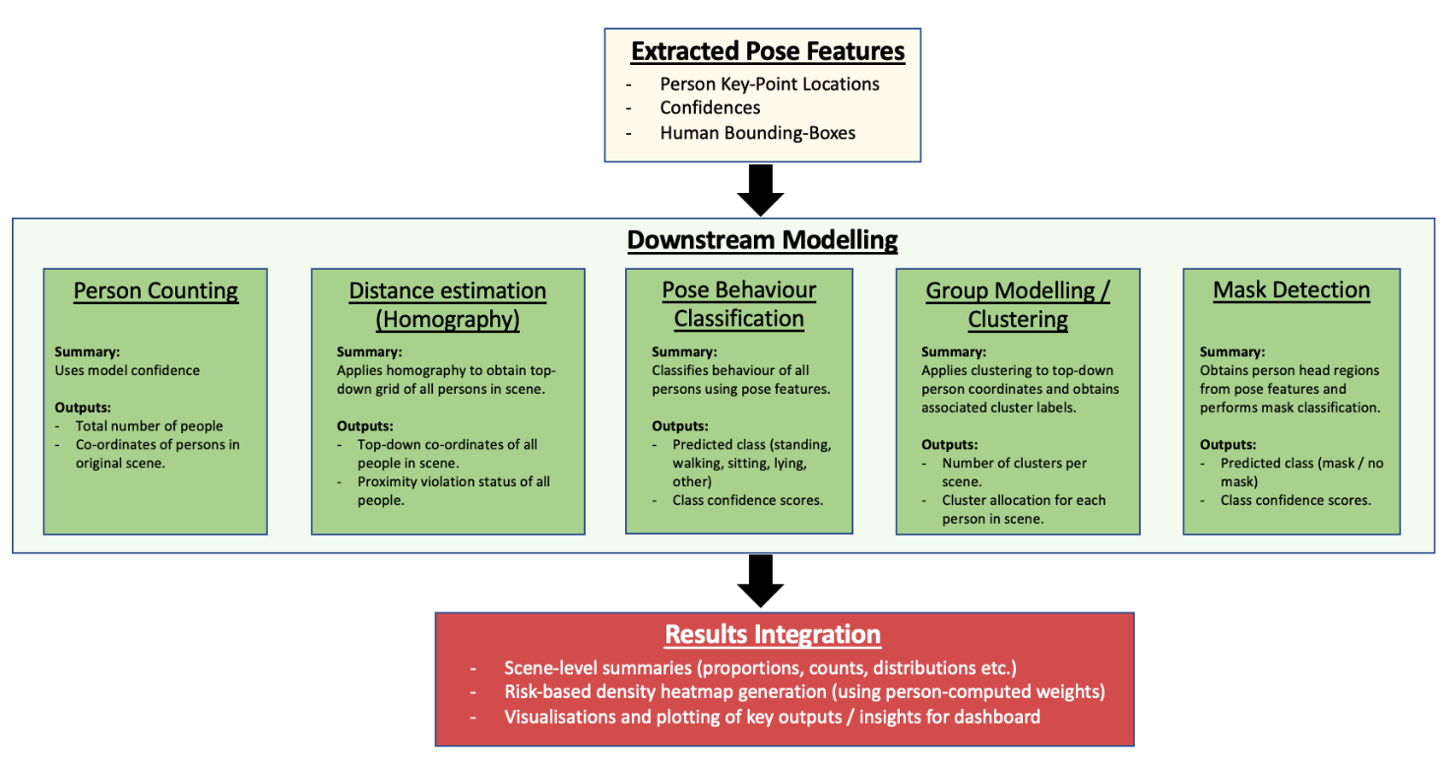

**Figure 6.** Summary of the system downstream models.

**3.2.2 Person counting from 2D scenes**

Since AlphaPose provides a set of key-points and co-ordinates for each detected person, along with person bounding boxes, counting the number of persons is trivial, since it is represented by the number of person results for each scene. This works well even for complex and distant scenes, as shown in Figure 7.

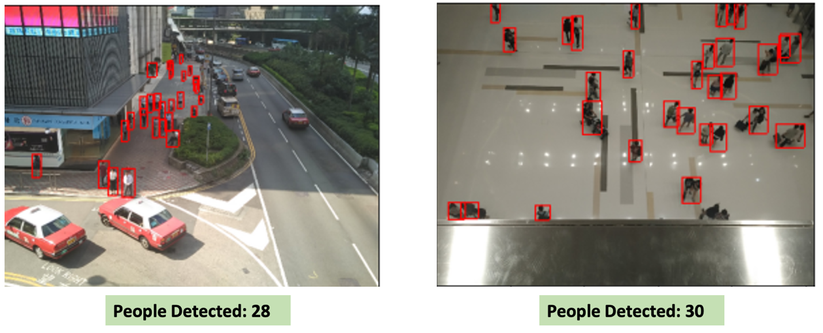

**Figure 7.** Examples of person counting using the results from the AlphaPose modelling pipeline.

A person-bounding box confidence threshold of 0.5 was used for including a prediction into the calculation for total persons detected in a scene. This reduced the number of false positives and low-confidence erroneous bounding boxes that were included in the final count.

**3.2.3 Distance estimation within 2D scenes**

**[Section developers - Valentin / Gurpreet]**

The purpose of the distance estimation is to determine the distance between people detected in a scene and predict whether they are violating social distancing or not. This can then be exploited to give the proportion of people violating the social distancing policy and the number of clusters identified.

In existing works, this is performed with two different methods. The first one consists in using the height and width of the persons' bounding boxes to estimate the distance between them. The second method is based on the camera parameters and computes the positions of the persons in the 3D scene from their positions in the 2D scene and the camera parameters. This project is using a novel approach, where the extracted pose features are used to determine the camera parameters which then give the homography needed to obtain the positions of the persons in the 3D scene. These finally allow the distances estimation and the clustering.

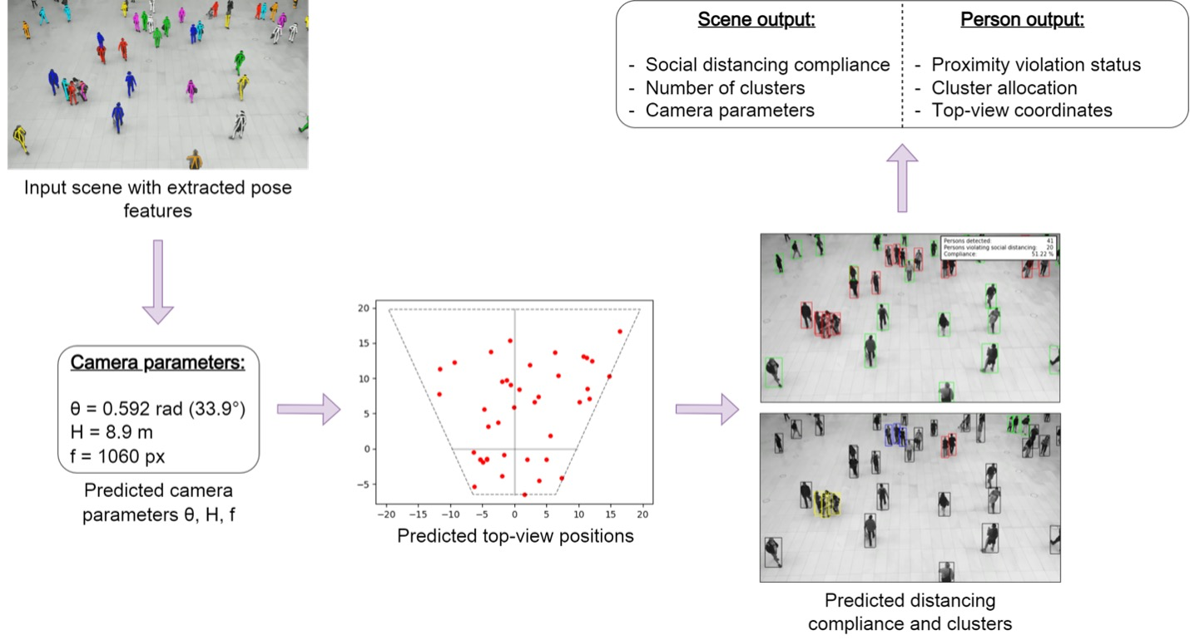

**Figure 8.** Overview of the distance estimation pipeline.

The camera parameters are:

* $θ$: tilt angle
* $H$: height
* $f$: focal length

In this model, in order to perform the homography, the detected persons must be on the same plane, meaning that there must not be two floors on the same view, $H$ needs to be greater than the height of each person and $θ$ must belong to the interval [$0, \frac{π}{2}$] which means the camera must face the ground, even very slightly. In addition, the model is valid for a no fisheye camera: if this is the case, a simple recalibration of the image would remove lens distortion.

The position of an object in the image is given by its position $\left(x, y\right)$ according to the centre of the image $O_{image}$. The position of an object in the 3D coordinate system is given by its Cartesian coordinates $\left(X, Y, Z\right)$, where the origin of this coordinate system $O$ will be projected on the origin of the image coordinate system $O_{image}$ with the camera view. The image obtained with a camera is the projection of the 3D objects on its focal plane, as shown in Figure 9.

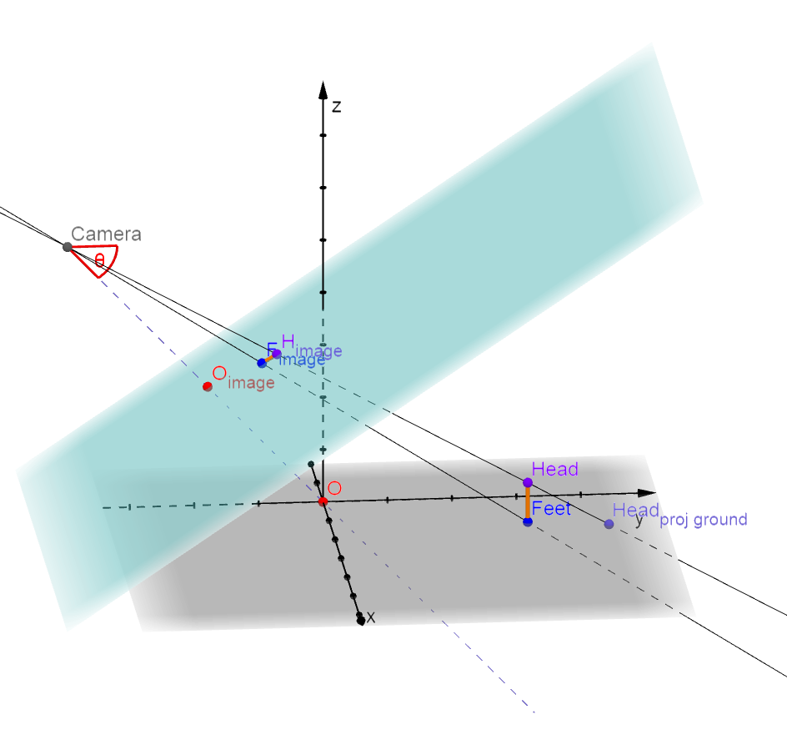 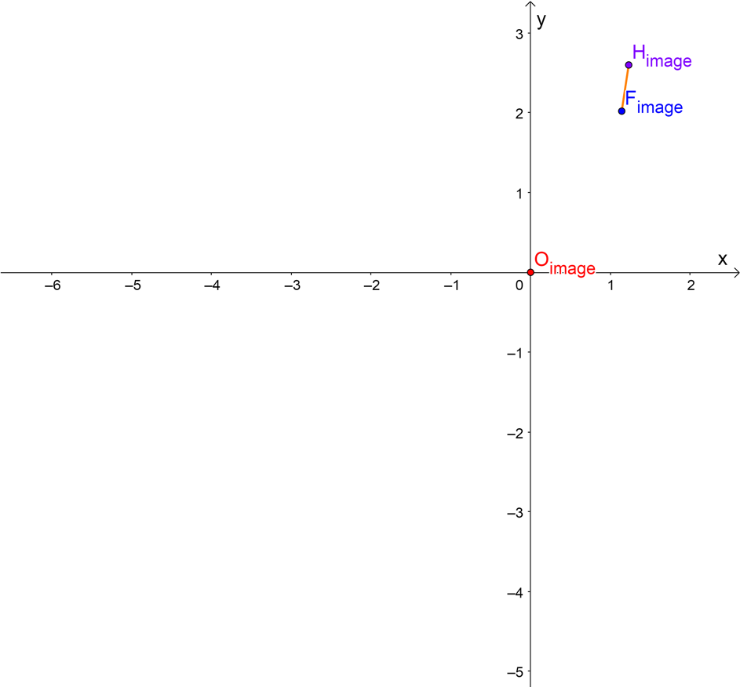

**Figure 9.** Visualisation of the camera focal plane projection (3D view and image view).

The homograpic relations between the image position $\left(x, y\right)$ and the 3D position $\left(X, Y, Z\right)$ are given by the following formulas:

$x=fX\frac{\sin\left(θ\right)}{H+Y\cos\left(θ\right) \sin\left(θ\right) - Z \sin^{2}\left(θ\right)}$ (1)

$y=f\left(Y\sin\left(θ\right) + Z\cos\left(θ\right)\right)\frac{\sin\left(θ\right)}{H+Y\cos\left(θ\right) \sin\left(θ\right) - Z \sin^{2}\left(θ\right)}$ (2)

These relations are therefore used to estimate the camera parameters from the head and feet positions of the persons detected in the input image. Then they will be used with the estimated camera parameters to determine the positions on the scene of the different persons.

The calculation of the distances is now trivial, and the clustering is also done directly from the latter. In particular, the DBSCAN algorithm will be used, since it is a density-based clustering algorithm where a threshold can be set to specifies the maximum distance between two people for them to be considered as being in a close neighbourhood in the sense of a social cluster.

The advantage of this distance estimation method is that it allows us to dispense with the camera parameters, which can be laborious to measure, especially when there are many cameras as in an airport. Moreover, it allows our model to be more robust, because the parameters are updated as we go along to adapt to possible changes in time of the parameters, voluntary or not. In addition, it is more accurate than a system that only considers bounding boxes to calculate distances between people, which is very sensitive to perspective effects and AlphaPose feature selection errors.

This method is most effective when used with video sequences, rather than static scenes, as the predictions of the camera parameters can be averaged over time to improve and smooth the results.

The modelling used to develop the distance estimation module is detailed in Section 4.

[inverse homography]

**3.2.4 Pose Behaviour Classification**

**[Section developers - Tongfei]**

In crowded public spaces, people with different behaviours should have different social distance restrictions. In this system, pose behaviour classification needs to classify the behaviours of all detected people in a scene and give different social distance risk weights to people of different behaviour classes. Behaviours are divided into five classes, including standing, sitting, walking, lying and others, as shown in Figure 10. The “others” refers to other behaviours or the incomplete pose features that human cannot distinguish too.

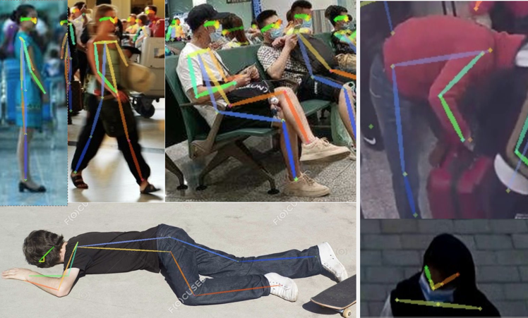

**Figure 10.** Examples of five classes.

In the process of pose behaviour classification (as shown in Figure 10), firstly, obtain the posture features and bounding box information of all people in the scene from AlphaPose, and then pre-process them and send them as input to the pre-trained fully connected neural network. Finally, the pose behaviour classification results and confidence scores of each person are obtained.

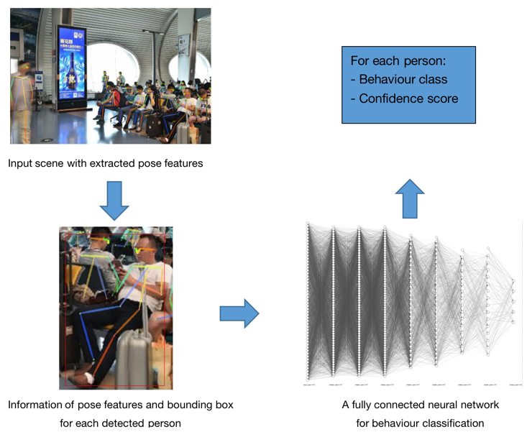

**Figure 11.** Overview of the pose behaviour classification module pipeline.

Pose feature information includes the coordinates and confidence scores of feature key points. They are the most important and core input feature, which provides the basis for pose behaviour classification. The information of the bounding box can effectively screen out the abnormal human detection results from AlphaPose and distinguish similar behaviours such as between standing and walking. The coordinates of pose feature key points need to be centred and normalized to improve the performance of the model. There is no huge order of magnitude difference in other input features, so there is no need for normalization.

Because the input features are obtained from a huge model, AlphaPose, the pose behaviour classification model adopts a simple fully connected neural network, which can also get great results after adjustment and meet the potential needs of real-time analysis.

**3.2.5 Mask Detection**

The purpose of the mask detection module is to analyse all people detected in a scene and predict whether they are wearing a mask or not. This can then be exploited to provide indications of what proportions of people in a scene are wearing a mask or not, along with where they are located.

The reasoning behind this aspect of the system is that when social distancing and safety is important, for example during pandemics, the use of face masks has been shown to have measurable benefits to reducing the spread of airborne particulates, including [insert references to works on masks, proving they are important when social distancing is a concern]. Due to these added safety benefits, being able to accurately identify whether individuals in a scene are wearing masks or not could prove valuable for a social-distancing crowd monitoring platform, since this can be factored into the risk-based assessment and calculations for each scene.

Many works have tackled this problem in recent years, which have usually applied an object detection model over an entire scene to detect each mask. This project instead proposes a novel approach, where the extracted pose features are used to obtain suitable head regions for all people in a scene. These small regions are then fed into a mask image classifier, which predicts the likelihood of a mask being present or not (Figure 8).

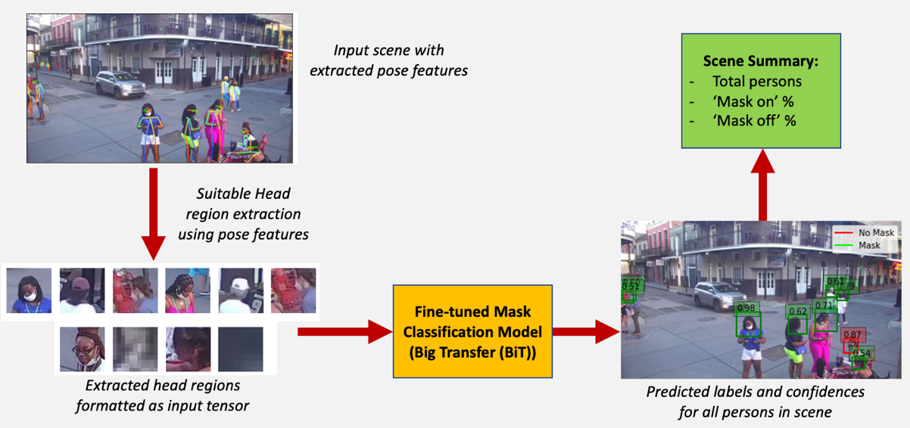

**Figure 12.** Overview of the mask classification module pipeline.

The process of extracting head regions as described is illustrated in Figure 13.

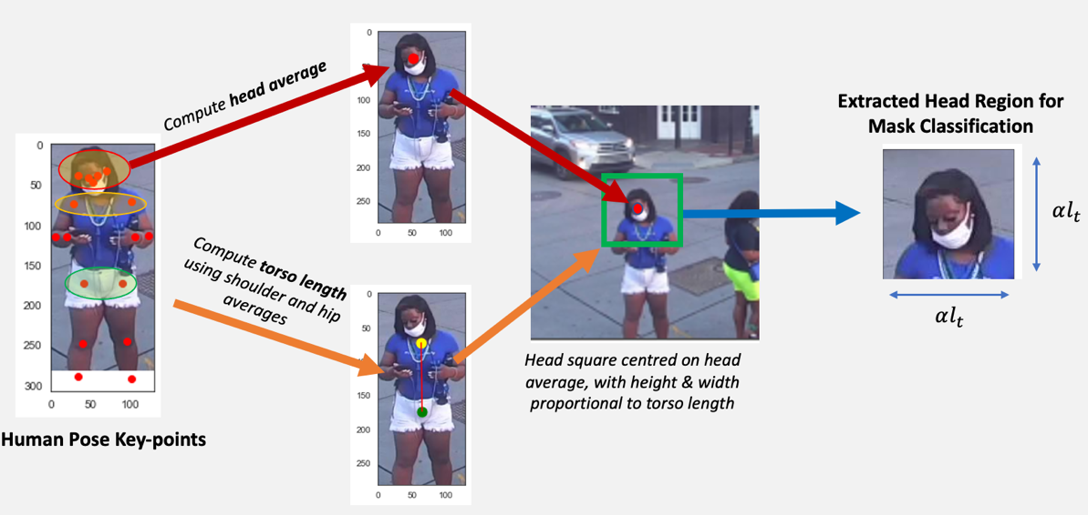

**Figure 13.** Overview of the mask classification module pipeline.

This process involves computing the average head key-point positions using the head key-point features. Additionally, the average shoulder and hip co-ordinates are computed, which are used to approximate the torso length, as follows:

$Torso Length, l_{t}=\sqrt{{\left(x_{shdr}-x_{hip}\right)}^{2}+{\left(y_{shdr}-y_{hip}\right)}^{2}}$ (3)

Where $x_{shdr}$ and $y_{shdr}$ are the average x and y shoulder co-ordinates, and $x_{nip}$ and $y_{hip}$ are the average x and y co-ordinates for the hips.

The extracted head region is then determined by using a square centred on the average head co-ordinates, with a height and width equal to the torso length multiplied by a scaling factor, as follows:

$Region Square Length=αl_{t}$ (4)

Where $α$ is a scaling factor, which was set to 1.1 for the project pipeline.

This process is advantageous compared to object detection for many reasons. The first is that it performs classification on small image regions, which is faster and more efficient for large scenes. This improves performance and simplifies modelling dependencies, which allows for real-time inference. Secondly, this directly leverages the pose extracted features, since it obtains suitable head regions of all people based on the computed torso height and average head key points. This also allows faces to be directly attributed to the associated pose features, which was found to be very challenging using an object detector. Thirdly, the classification task is simpler to evaluate, in contrast to more complex object detection metrics.

The design of this module also benefitted naturally from video sequences, rather than static scenes, since the often noisy predictions obtained from complex environments can be averaged over time to provide smoothing and less extreme results for a scene.

All data and modelling used for developing the mask detector is detailed in Section 4.

## 3.3 Phase 3: Integration of results into a dashboard application

**3.3.1 Results Integration Introduction**

**[Section developer – Orhan]**

Spread of respiratory diseases such as covid has been demonstrated to be caused significantly by coughing. Several studies on the effects of coughing and diffusion of particles resulting from coughing exists in which simulation and computational data shows the range of contamination from such particles [5, 6]. In research from (Muthusamy et al., 2021) both experimental and computational study shows that the distribution of particles expelled from the mouth can travel up to 3.9 meters from a standing position.

|  |
| --- |
|  |
|  |

**Figure 14.** Effusion of a cough cloud in standing position, un-masked at (a) 1 seconds, (b) 5 seconds and sitting position at (c) 1 seconds, (d) 30 seconds.

Furthermore, due to the buoyancy of light particles expelled from the mouth some particles coalesce after rising through the air and, at which point they fall once their buoyancy decreases far enough. Due to this phenomenon, a person in sitting position grants the particles more vertical distance to travel before they leave the height at which they can still contaminate other subjects. Figure 14 visually explains the difference sitting and standing make on the maximum range cough droplets can traverse.

|  |
| --- |
|  |

**Figure 15.** Cough particle spread comparison between standing and sitting positions. MAX represents maximum particle travel distance.

Data from (Muthusamy et al., 2021) is used as the basis for the factors $τ_{dist}$, $τ_{mask}$ and $τ_{pose}$. These factors then are used to compute the risk-based weights of the risk density heatmap.

**3.3.2 Risk Density Heatmap**

The outputs from the downstream models were combined to estimate the risk profile for a given input scene. The chosen method of doing this was to a generate density heat-map using weighted Kernel Density Estimation (KDE), which used a novel method for computing weights based on the social-distancing risk features extracted. A standard KDE model can be defined as (Murphy, 2022, p. 554):

$p\left(x \right| D)=\frac{1}{N}\sum_{n=1}^{N}{K_{h}(x-x_{n})}$ (5)

*Where $x$ is the input feature vector, $x_{n}$ is the input feature vector for the nth sample, N is the total number of samples in the dataset $D$, and $K_{h}$ is the chosen density kernel function.*

For this work, a Gaussian kernel was chosen, defined as follows (Murphy, 2022, p. 554):

$K_{h}\left(x\right)=\frac{1}{{h^{D}(2π)}^{D/2}}\prod_{d=1}^{D}{exp\left(-\frac{1}{2h^{2}}x_{d}^{2}\right)}$ (6)

*Where $h$ is a bandwidth parameter representing the width of the kernel.*

[Add reasoning for bandwidth]

This allocates a gaussian-based cluster to all data points to estimate the density. This work also introduced risk-proportional weights to each sample, $α_{risk}$, which gives:

$p\left(x \right| D)=\frac{1}{N}\sum_{n=1}^{N}{{α_{risk}K}_{h}(x-x_{n})}$ (7)

The data samples, $D$, were the 2D co-ordinates of each person in the top-down representation of each scene. The sample weights, $α_{risk}$, were then computed for each sample, based on whether that person was violating distance, wearing a mask, and their current pose status. The definition of a risk-based weight for each person is defined as follows:

$α_{risk}\left(x\right)=Ι_{vio}\left(x\right)\left[τ_{dist}+Ι_{no_mask}\left(x\right)τ_{mask}+Ι_{pose_risk}\left(x\right)τ_{pose}\right]$ (8)

*Where $Ι_{vio}$ is an indicator function (0 or 1) for whether a person is violating distance, $Ι_{mask}$ is an indicator function for a person with no mask, $Ι_{pose_risk}$ is an indicator function for a higher-risk pose, $τ_{dist}$ is a chosen distancing factor, $τ_{mask}$ is a mask-usage factor, and $τ_{pose}$ is a pose status factor.*

For a given scene, all persons that are isolated and well-distanced from others, according to a defined distance (such as 2.0 m), are assigned a weight of zero. This is ensured by the violation indicator function:

$Ι_{vio}\left(x\right)=\left\{\begin{aligned}1 \\ 0\end{aligned}\right. \begin{matrix}if x<2.0 m of others \\ if x≥2.0 m of others\end{matrix}$ (9)

At that instance in time, the risk is zero for that location and no contribution is made towards the risk density heatmap if no violation is made. Conversely, those persons in close proximity will be assigned a risk-based weight, which is computed based on whether that person is wearing a mask ( $Ι_{no_mask})$ and whether they are predicted in a more risky pose behaviour ($Ι_{pose_risk}$). The influence of each social distancing factor on the final weight is determined by the specific factors chosen for each: $τ_{dist}$, $τ_{mask}$, and $τ_{pose}$.

Computing weights for each sample in this way produces a 2D risk matrix for each scene, where higher values represent more risky areas within that scene. A simple example is shown in Figure 16.

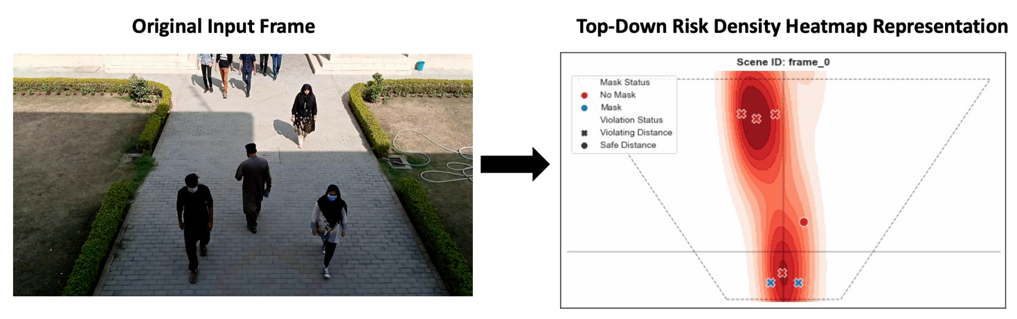

**Figure 16.** Example of the risk density heatmap on the top-down perspective of a scene.

These concepts were then extended to video sequences through defining a 3D tensor, which contained timesteps in the first dimension, followed by the associated 2D risk matrix for the remaining dimensions. The principle behind this is that a risk profile heatmap can then be generated and summarised over a designated time-period, rather than only at instantaneous moments in time. More usefully, this was also projected to the original scene, rather than from a top-down perspective, as shown in Figure 17.

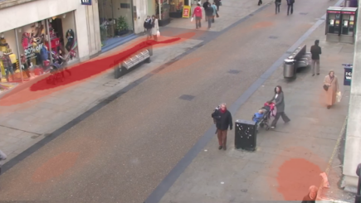

**Figure 17.** Example of projecting an averaged heatmap over all timesteps on original scene.

This allows for much more useful analysis by the airport, since it would enable staff to visualise the risk areas at specially chosen time-periods and durations throughout the day.

**3.3.3 Dashboard Application**

**[Section developer – Orhan]**

The application is an interactable interface designed to integrate all the downstream outputs to a single viewport. The code for the dashboard has been uploaded to GitHub and is available at: <https://github.com/biantongfei/GDP_group5>.

The app uploads data files created by the downstream models to the dashboard in real time so that analsyis on the current state of the scene can be made. At any given time, the original footage of the scene can be seen, along with either the pose features extracted from each person on a player adjacent to it. Statistics regarding the scene are displayed on the very right of the viewport. These statistics are;

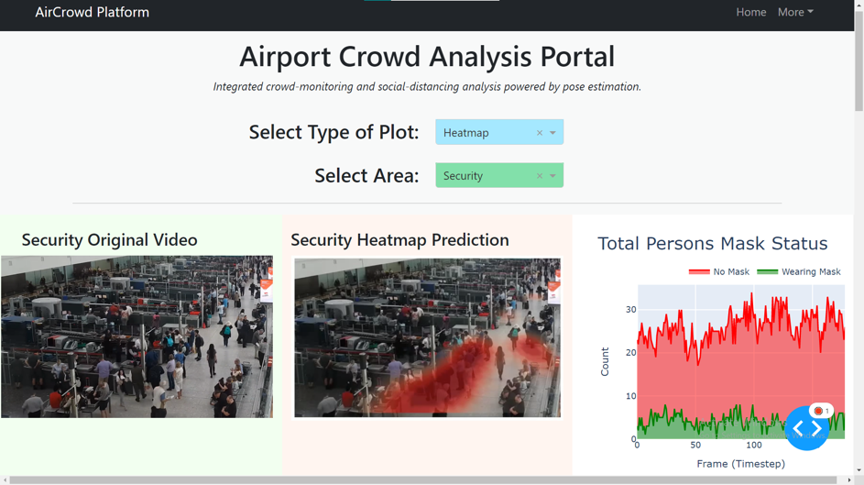

**Figure 18.** The dashboard application displaying the CCTV footage, the heatmap prediction and various statistics.

|  |  |
| --- | --- |
| (a) | (b) |
|  |  |
| (c) | (d) |
|  |  |
| **Figure 19.** Dashboard displaying the scene at (a) 1 seconds, averaged risk-regions at (b) 5 seconds, (c) 10 seconds and (d) all timesteps. | |

|  |
| --- |
|  |
| **Figure 20.** The dashboard application displaying statistics about the scene. |

[Add stuff]

[Part 3 should be ~2000 – 2500 words total It’s 3500 now]

# 4. Experimentation and Modelling

**[Entire section 4 development by Ben, Valentin, Gurpreet and Bian as required]**

## 4.1 Experimentation Introduction

[Discussion on how we designed our experiments for the system, and what these involved. This should be a precursor to how we developed and tested the system, and obtained the results that we will be discussing below]

All project modelling was developed using Python open-source packages, including NumPy (Harris et al., 2020), Pandas (Mckinney, 2010) and SciPy (Virtanen et al., 2020).

The code was developed using a team repository on GitHub, which has been made available at: <https://github.com/biantongfei/GDP_group5>.

The final system modelling process consists of one large loop, which takes an input video feed and processes this into image frames at a chosen frames-per-second, followed by extracting pose features from each frame, applying downstream modelling on the obtained pose results, and finishing by integrating the collective results into a set of outputs suitable for display on the dashboard. The finer details of each of the modelling processes used for this will be described in the following sections.

[Datasets summary]

Summary of how many datasets were required throughout the project, what these are, where they were obtained from, and how they were used, including references. Would be best illustrated using a table of data sources used by all members of the team...

## 4.2 Multi-Pose Crowd Estimation Methodology

For the final system, the open-source Python framework GluonCV (Guo et al., 2020) was used to develop the AlphaPose pipeline, using an MXNet backend for the object detection and pose-estimation phases. For the initial object detector a YOLOv3 model with Darknet-53 pre-trained weights was used (Redmon and Farhadi, 2018), since this represented the best compromise between detection performance and speed for the system pipeline.

Since the system inputs are video feeds, a suitable modelling process was designed to work with sequences, rather than static images. This included processing the current input video source into image frames at a chosen frames-per-second, as shown in Figure 21. In addition to those open-source packages mentioned above, this was performed using OpenCV (Bradski, 2000).

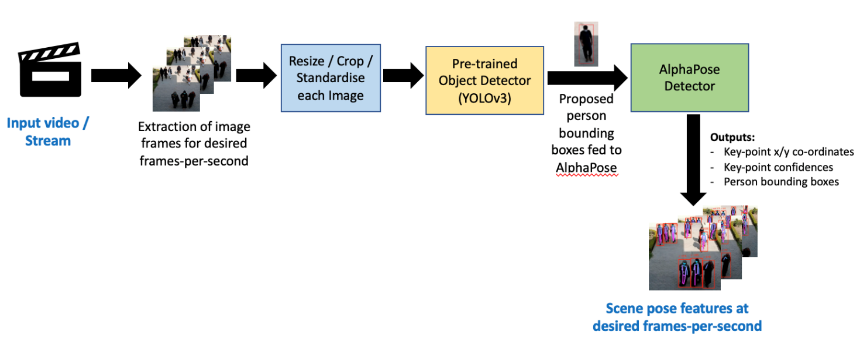

**Figure 21.** Pose-estimation pipeline used to process video inputs.

After obtaining the pose features for each frame in real-time (Figure 21), the results were passed to the downstream models for further processing, which will be discussed next.

## 4.3 Downstream Modelling Methodologies

[narrative of how modelling was performed for each downstream model, including datasets used, libraries, model architectures, preprocessing, strategies and so on. **Rather than the technical theory (covered in the previous section), this should contain what you actually did using code and how this worked**]

**4.3.1 Distance Estimation Modelling**

**[Section developers – Valentin & Gurpreet]**

The distance estimation is based on the homographic relations between the image position and the 3D position given in Section 3. In particular, since the pose features give head and feet positions in the image of each person detected in a scene, respectively $\left(x_{h}, y_{h}\right)$ and $\left(x_{f}, y_{f}\right)$, for a person of size $h$ > 0 located on the ground on position $\left(X, Y\right)$, the relations are:

$x_{f}=fX\frac{\sin\left(θ\right)}{H+Y \cos\left(θ\right) \sin\left(θ\right)}$ (xx)

$y_{f}=fY\sin\left(θ\right)\frac{\sin\left(θ\right)}{H+Y \cos\left(θ\right) \sin\left(θ\right)}$ (xx)

$x_{h}=fX\frac{\sin\left(θ\right)}{H+Y \cos\left(θ\right) \sin\left(θ\right) - h \sin^{2}\left(θ\right)}$ (xx)

$y_{h}=f\left(Y\sin\left(θ\right)+h\cos\left(θ\right)\right)\frac{\sin\left(θ\right)}{H+Y \cos\left(θ\right) \sin\left(θ\right) - h \sin^{2}\left(θ\right)}$ (xx)

If $x_{f}≠0$ and $x_{h}≠0$, this leads to the equations:

$X=\frac{x_{h} h}{\sqrt{{\left(f\left(1-\frac{x_{h}}{x_{f}}\right)\right)}^{2}+{\left(y_{h}-y_{f}\frac{x_{h}}{x_{f}}\right)}^{2}}}$ (xx)

$Y=\frac{X y_{f}}{x_{f} \sqrt{1-{\left(\frac{X}{h}\left(\frac{y_{h}}{x_{h}}-\frac{y_{f}}{x_{f}}\right)\right)}^{2}}}$ (xx)

$θ=\cos^{-1}\left(\frac{X}{h}\left(\frac{y_{h}}{x_{h}}-\frac{y_{f}}{x_{f}}\right)\right)$ (xx)

$H=\frac{X}{x_{f}}\left(f\sqrt{1-{\left(\frac{X}{h}\left(\frac{y_{h}}{x_{h}}-\frac{y_{f}}{x_{f}}\right)\right)}^{2}}-y_{f}\frac{X}{h}\left(\frac{y_{h}}{x_{h}}-\frac{y_{f}}{x_{f}}\right)\right)$ (xx)

Thus, for each person in a scene and for a given focal length $f$, from their head and feet coordinates in the image $\left(x_{h}, y_{h}\right)$ and $\left(x_{f}, y_{f}\right)$, it is possible to determine their 3D positions on the ground $\left(X, Y\right)$ and the camera parameters $θ$ and $H$.

There are two error sources in this method. The first one is that the image coordinates that are not exactly the projected coordinates of the persons since AlphaPose is approximating the positions of the head and feet. The second one is the heights of the persons fixed as the average size of people, but they rather follow Gaussians distributions. That is why for a given frame, the set of predicted parameters (predictions for each person) will be used to determine the camera parameters more accurately, as well as the positions of the persons, as shown in Figure 22.

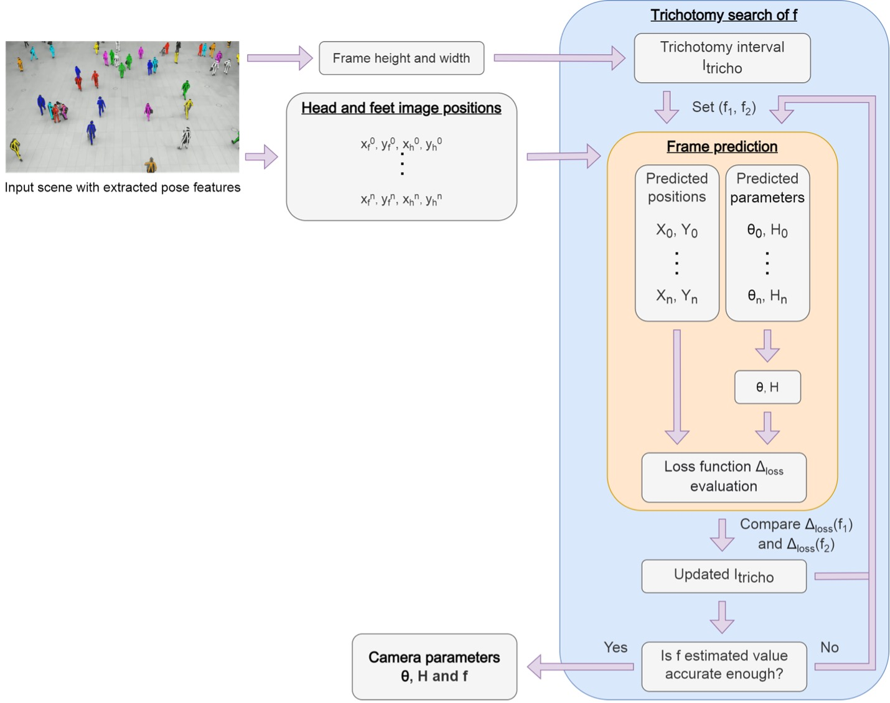

**Figure 22.** Overview of the parameters’ estimation

This means that for each frame, we have the camera parameters determined from each person and the camera parameters determined by the set of persons, all at a fixed *f*. The idea is that, as *f* approaches its real value, the camera parameters determined from each person will be closer to the parameters determined by the set of persons, which will themselves be closer to the real values. The loss function $Δ_{loss}$ used is the distance on the image between the input detected feet position and the feet position determined with the predicted individual positions and the camera parameters estimated with the set of persons.

$$Δ_{loss}\left(f\right)=Median Squarred Error \left(f\right)$$

$$Δ_{loss}\left(f\right) =Median Squarred Error \left(f\right)$$

Then talk about:

- determination of f

- loss (and properties => for trichotomy for ex)

-> determination of Xpers, Ypers, Thetapers and Hpers

-> determination of Theta, H (formula median (+why) + remove outliers (+why))

- trichotomy

- final parameters (formula density (+why) + remove outliers (+why)) then position (then distance and clusters)

METRICS + PRECISION PART

**4.3.2 Group Clustering Modelling**

**[Section developers – Valentin & Gurpreet]**

**4.3.3 Pose Classification Modelling**

**[Section developer – Bian]**

The pose behaviour classification model is used to classify the behaviours of detected people in each frame. The data set of this task used videos with an appropriate number of people and various types of behaviour in the scene from the open-source monitoring video databases of crowds in public spaces. Using AlphaPose to analyse each frame of the selected videos, getting the information on pose features and bounding boxes of each people in the frame. The final data set consists of 548 frames, including 8484 detected people. Among them, there are 2548 standing, 673 sitting, 3582 walking, 201 lying, and 2480 other examples.

The pose classification model is a fully connected neural network. In addition to the coordinates of 17 pose feature key points, its input also includes the confidence score of 17 key points, the aspect ratio of its bounding box, and the ratios of the bounding box size to the frame size.

The aspect ratio:

$\frac{Width_{bbox}}{Height_{bbox}}$ (xx)

The ratios of the bounding box size to the frame size:

$\frac{Width_{bbox}}{Width_{frame}}$ (xx)

$\frac{Height_{bbox}}{Height_{frame}}$ (xx)

So, its input has 54 dimensions. Introducing the confidence score of key points helps the model pay more attention to high-score key points and avoid the impact of possibly wrong low-score key points on the classification results. The introduction of the aspect ratio of bounding boxes helps the model better distinguish similar behaviours, such as standing and walking. Introducing the ratio of the bounding box size to frame size helps the model better identify the occluded or incomplete human bounding boxes and classify them as "others". The impacts of introducing these features as model inputs on accuracy are shown in the Table 3.

|  |  |  |  |  |
| --- | --- | --- | --- | --- |
|  | Only Coordinates | Add Confidence | Add Aspect Ratio | Add bounding box size rate |
| Accuracy | 78.52% | 87.13% | 91.87% | 93.04% |
| Loss | 0.531 | 0.331 | 0.247 | 0.213 |

**Table 3**. Impact of introducing features

In addition to the coordinates of pose feature key points, the value range span of other input features is very small, which does not affect the performance. Only the coordinates need to be centered and normalized by using the bounding box to make their value range in [0,1]:

$X_{normalized}=\frac{X_{original}-X\min_{bbox}{}}{Width_{bbox}}$ (xx)

$Y_{normalized}=\frac{Y_{original}-Y\min_{bbox}{}}{Height_{bbox}}$ (xx)

The data is divided into the training set, verification set, and test set according to the ratio of 7:3:1 to select the model structure and hyperparameters. Finally, the optimal model is a fully connected neural network with seven hidden layers. The structure is shown in the Figure 13.

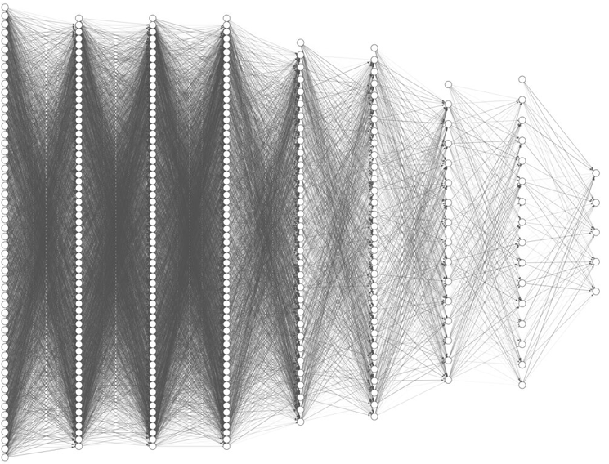

**Figure 23.** Structure of pose behaviour classification model

After 120 epochs of training, the accuracy of the pose behaviour classification model on the test set reached 93.04%, and the training process is shown in Figure 14. From the confusion matrix (shown in Figure 15), the model is still more prone to error when distinguishing between standing and walking. Because the model adopts a simple neural network, it does not need a lot of calculation, and the prediction speed is more than 32 people per millisecond.

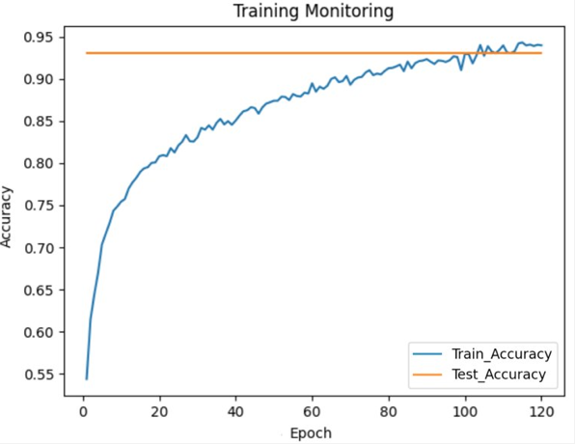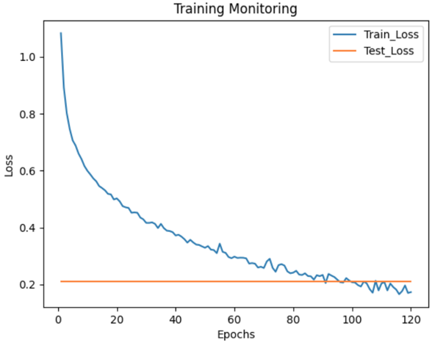

**Figure 24.** Accuracy and loss during training process.

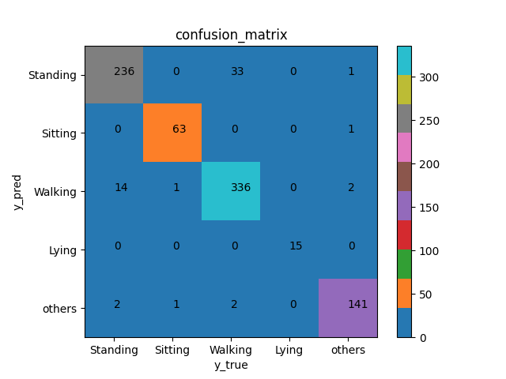

**Figure 25.** Confusion matrix of pose behaviour classification model.

**4.3.4 Mask Detection Modelling**

The mask classification model was trained using a specially curated mask classification dataset. This was developed using multiple open-source mask object detection datasets and processing these into a unified mask classification dataset of 11,261 images, with 7967 masked and 3294 non-masked samples. Each image was curated using the mask bounding box co-ordinates to extract head regions similar to those extracted from pose features (Figure 12).

The data was split into training, validation and test partitions, with the training and validation splits used to train and iteratively tune the model, and the held-out test used to quantify final classification performance. This general modelling process used is illustrated in Figure 26.

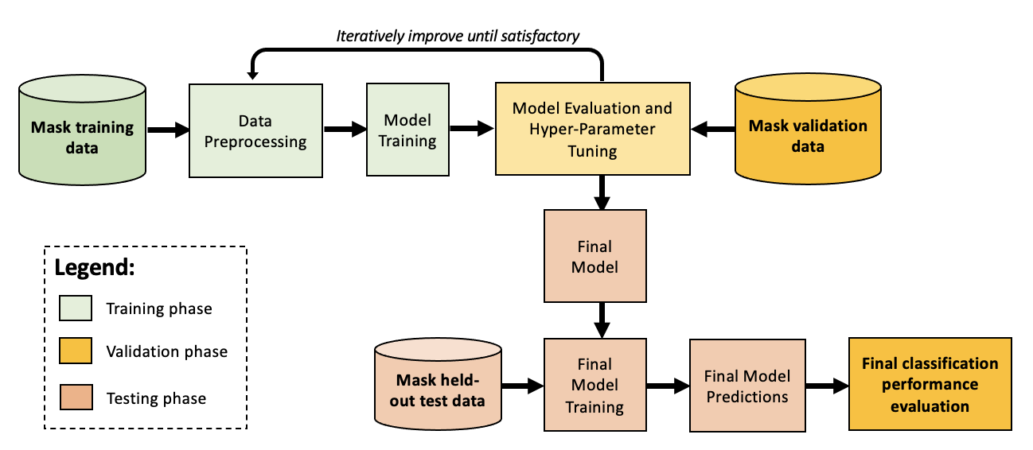

**Figure 26.** Summary of the mask classification modelling process.

Transfer learning and fine-tuning was used for model development. This was achieved using a BiT-M R50x1 architecture pre-trained on the ImageNet-21K dataset and following the Big Transfer fine-tuning and optimisation process proposed by Kolesnikov et al (2019). The model was coded using Keras (Chollet, 2015) and TensorFlow (Abadi et al., 2015).

The loss for training was the categorical cross-entropy, defined between the true and predicted labels as follows (Géron, 2019, p. 149):

$L\left(y,\hat{y}\right)=-\sum_{i}{y_{i}}log⁡({\hat{y}}_{i})$ (xx)

*Where $y_{i}$ and ${\hat{y}}_{i}$ are the true and predicted labels for the $i^{th}$ instance, respectively.*

The outputs were logits by default, and so a custom softmax layer was added to provide a probability distribution over the class labels, defined as follows (Géron, 2019, p. 148):

${\hat{p}}_{k}=σ{(s(x))}_{k}=\frac{e^{(s_{k}(x))}}{\sum_{j=1}^{K}{e^{(s_{j}(x))}}}$ (xx)

*Where K is the number of classes, $s(x)$* *is the vector of class scores for* ***x****, and $σ{(s(x))}_{k}$ is the predicted probability that x belongs to class k.*

For model performance assessment various classification metrics were used, including accuracy, precision, recall, F1-score and the Receiver Operator Characteristic (ROC). Precision and recall are suitable for imbalanced datasets, including this mask dataset. These consider the True Positives (TPs), False Positives (FPs) and False Negatives (FN). Precision is the proportion of predictions correctly classified positive out of all positive predictions made, whilst recall is the proportion of instances predicted positive out of all positive instances. F1-score combines recall and precision, and thus acts as a good compromise of both. Each of these are defined below:

$Accuracy=\frac{TP+TN}{TP+TN+FP+FN}$ (xx)

$Precision=\frac{TP}{TP+FP}$ (xx)

$Recall=\frac{TP}{TP+FN}$ (xx)

$F_{1}=2×\frac{Precision×Recall}{Precision+Recall}$ (xx)

*Where TP, TN, FP and FN are the True Positives, True Negatives, False Positives and False Negatives, respectively.*

The specified threshold for classifying masks also impacts the performance, and therefore the Receiver Operating Characteristic Under the Curve (ROC AUC) was also computed. This ranges from 0 (worst) to 1 (best) and quantifies how well the True Positive Rate (TPR) is relative to the False Positive Rate (FPR) over all thresholds.

For mask detection, it was deemed more important to have less false positives (predicting a mask) relative to false negatives (predicting no mask). This is because if someone is predicted as masked, their relative risk factor is lower than someone without a mask. Therefore, if there is ambiguity for a given prediction, it is safer to conservatively assume no mask. Thus, the model should prioritise performance at correctly predicting a mask. For this reason, ensuring a high precision was the largest priority during evaluation and assessment of metrics.

The loss and accuracy results throughout fine-tuning training for the mask classifier are given in Figure 27.

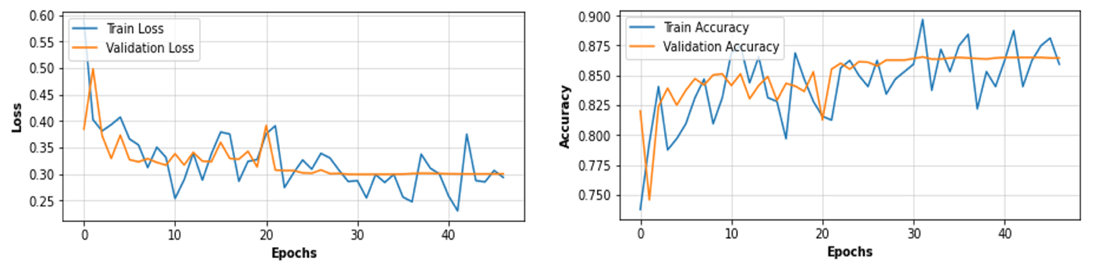

**Figure 27.** Summary of the mask classification modelling process.

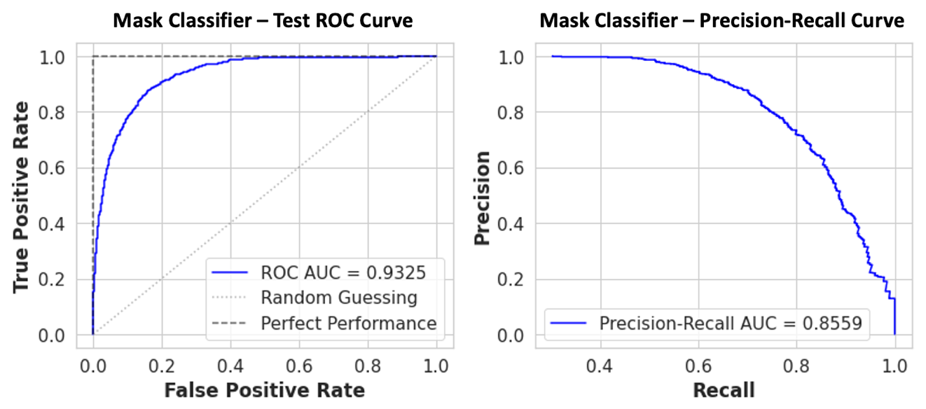

**Figure 28.** BiT mask classifier final results on the held-out test set.

To obtain the best compromise of precision and recall, the mask prediction probability threshold was optimised using the ROC curve, which produced the confusion matrix results shown in Figure 15.

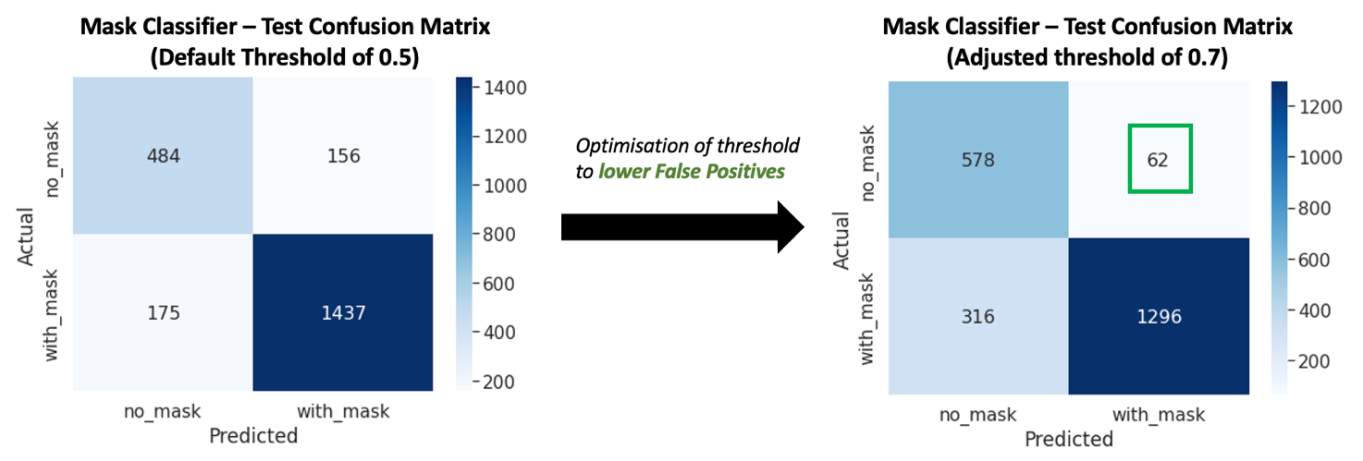

**Figure 29.** BiT mask classifier final confusion matrix on the held-out test set.

This optimisation prioritised reducing the number of FPs (predicting non-masked persons as masked) at the expense of accepting more FNs (predicting masked people as non-masked). This trade-off and adjustment was important, since a FP is considered more costly than a FN for the system. Therefore, precision was most important, but at the same time it was important to retain a sufficient level of recall to remain useful.

## 4.3 Testing and Validation Strategies

Suitable validation and testing strategies were developed for all models within the overall system framework. Since the downstream tasks varied considerably, different techniques for evaluating each model were required, as explained in each of the modelling sections previously. Furthermore, the overall system acts collectively with all of the models, and therefore strategies were also needed to test and evaluate the final system in terms of performance and suitability for use against the stakeholder requirements.

To address these needs, an integrated testing and evaluation plan was developed, which drew heavily from the initial requirements (Table 1). This encompassed the main areas throughout the project that would require testing, along with the strategies that would employed to accomplish this. Ultimately, the aim of testing and validation was to provide assurance that the overall system was suitable and fulfilled the specified requirements. The final integrated test and evaluation plan, which also includes indication of the final compliance results for each test, is provided in Annex C.

As shown....[discussion of key results in test plan – some points were partially non-compliant, which would require system improvements in practice. Also need to mention our final test data was not actually all airport context specific – we would need to gather more appropriate video datasets that are representative of an airport, and test the final system elements on this to get an idea of how it would actually perform in reality.]

## 4.4 Final System Demonstration and Results

[Final display of results from the dashboard and overall system – should include final tests (if we managed to perform them).

If not, it should include discussion of the results obtained using the dashboard on the final test video data

These results are then discussed in the final section, including how the system performs in reality, what could be improved, what works well, what else we could do with the system etc.]

## 4.5 System Results Discussions

[Actual discussions and insights on the key results summarised above.

This should include any limitations spotted on the system, and how these could be improved in the future.

It should also critique what worked well, along with how the system would need to be adapted to work for the true system as advertised (from a business perspective etc.)]

[group clustering based on time spent together?]

A limitation imposed on the system is the performance of the initial pose estimation algorithms, especially for complex and crowded scenes. The performance of all other models depends on the ability for poses to be successfully extracted for all persons in a scene, which is particularly challenging when using video surveillance viewpoints as considered in this work. It’s likely this could be improved through training of a custom trained version of the AlphaPose model, which has is tuned specifically on video camera surveillance scenes. Furthermore, the performance of AlphaPose is also reliant on the performance of the initial human object detector, and so it follows that improving this would also help improve the overall system performance.

Another limitation of the system is the difficulty in appropriately setting the risk factors for distance violation, mask-usage and pose behaviour. Discuss this further [as we were questioned in the final presentation]

[Another potential use for the system could be to generate a COVID risk score, based on the risk results.... discuss....]

A downside of the current system is the lack of person tracking. If tracking was incorporated further insights and useful information could be extracted from crowds. For example, this could include identifying groups or individuals that are consistently close to one-another, which might suggest they are travelling together and are therefore pose less risk to one-another. Furthermore, tracking could better help identify pose behaviour from individuals, such as whether they are moving, interacting physically with others, or performing particular actions. These insights and the movement of individuals could also identify key trends and behavioural patterns throughout particular areas in the airport, which would provide further benefits to the airport, from safety, planning and business-potential perspectives.

Finally, sequence tracking could improve the reliability and performance of mask-usage and behavioural classification, since it could average predictions for specific individuals over time, thus overcoming noise issues and anomalies where people are temporarily obscured or blocked from view.

[Part 4 should be ~2000-2500 words total]

# 5. Final Project Discussions

## 5.1 Summary of project achievements

**[Section developer – all team members]**

[Final project discussions about the system as a whole, e.g. its fitness for use / function, how it could be improved, what worked well, what didn’t.]

How it could be improved: Airports have a lot of blind spots due to the massive amounts of people that can gather at hot spots. Especially queues make it increasingly difficult to get accurate pose estimation. Multi camera system that can scan blind spots to increase accuracy? The model would have to identify and match individuals from two viewpoints based on coordinates and/or pose and/or visual identification. (Orhan: Keep it or remove it)

## 5.2 Real-World Deployment Considerations

**[Section developer – Brendan]**

To deploy the proposed system into production, many aspects beyond those mentioned in this work would need consideration, including....

* Continuous development / continuous integration
* Dataset monitoring, validation and versioning
* Model monitoring, re-training, validation and versioning.

## 5.3 Ethical Considerations

**[Section developers – Gurpreet, Brendan & Orhan]**

Data Protection Act of 2018 s 3 3(a), (b) defines “personal data” as identifiers, such as names, ID numbers, location data or factors specific to physical, physiological, genetic etc. Pose features the multi-person pose estimation model used in this system does not inherently store any data that can be used to identify data subjects. Raw data captured from cameras and/or retrieved from external sources are not required for the analysis’ done in the downstream modelling tasks, and thus can be discarded after the pose data is gathered from each scene.

Under the Data Protection Act of 2018s 14 4(a), (b) when a significant decision is made (significant decision being a decision that “produces legal effects concerning the data subject” or “similarly significantly affects the data subject”) purely automatically, the decision maker must disclose this action to the data subject as soon as possible. subsequently, the data subject can make an appeal for the reconsideration of the decision. This makes it exceedingly problematic to take automated decisions on individuals who are breaking the limits set up for social distancing, or any other restrictions the system is adopted for. Moreover, the system by no means enforces the data subjects to any actions, nor does it take any automated decisions that can significantly impact their lives, it’s barely a crowd monitoring and social distance analysis tool. The final result of the system merely gathers data about the hotspots and gathering places in a particular scene. If any action is to be taken against subjects breaking rules and breaching restrictions set by the controller, the decision must be made by a human monitor observing the analysis and data provided by the tool. The decision to take any action whatsoever against data subjects are up to the controller who uses the monitoring and analysis tool.

Under the Data Protection Act 2018 s 57 3, technical and organisational measures must be taken to only process personal data which is necessary for the specific purpose. As the mask detection with head region extraction model only uses pose key-points to compute and extract the head region for the classification model, no data is required to be saved in the process

It’s debated whether pose features alone can be used to identify individuals, and there exists several literature based on this method. These systems though work on the principle that at least a single image of the target, preferably the face, already is present in a database [3, 4]. Currently there are no tangible results on whether time-invariant pose features can be used to identify individuals. A single frame of a person’s joint locations alone should not be sufficient to identify them with the current technology we possess. Furthermore, as all four downstream models are time invariant, they are too not

[This should also highlight ethical concerns / other risks and problems that the system might bring in practice.]

## 5.4 Project Management and Team Reflections

Overall, the planned timescale of tasks and project deadlines was achieved to a good level by the team, although there were inevitably many unexpected issues and delays that occurred. Some aspects, such as the dashboard and final display of results, took much longer to experiment with and optimise, since delays occurred in integrating the separate elements and models of the system together.

Problems in setting up the hardware architecture and GPU environment also lead to last-minute changes by the team. This included running the final system pipeline on a CPU for demonstration, rather than the intended GPU. The result of this was a demonstration that could not be run in real-time, but nevertheless helped convey the value and benefits provided by the system, and how it would operate in practice. If the project was repeated, the procurement of hardware would be planned sooner, which could have prevented this issue.

Various aspects made team management difficult throughout, including the remote nature of team members and the occurrence of COVID-19 issues throughout. Although remote working between the team members worked, the consensus throughout the team is that it would have been more effective to have met and collaborated in person more often. This would have helped overcome many of the communication barriers inherent in remote teams, and would have helped streamline progression of many of the tasks, including the development and combining of different models to form the integrated system. Despite these issues and the circumstances mentioned, the team performed well and successfully progressed the project throughout.

## 5.5 Future Work, Improvements and Potential Applications

**[Section developer – Brendan, with input from others on modelling & technical perspectives]**

Use of tracking individuals over time would be extremely valuable, since it could provide advanced behaviour modelling for individuals and groups. For example, clusters of small numbers of people could be analysed over time to assess whether they are travelling together or not subject to their consistent movements and proximity. This help provide more realistic and usable results for the system risk heatmap.

Beyond the context of airports and social distancing, the project has huge potential. Although this work focussed on monitoring and improving public social distancing throughout airport areas based on video surveillance, the same system concepts could be applied to other domains, including town centres, public transportation areas, sports venues, music events and more. An example could be the adaptation to health and safety, where the workforce areas could be monitored for correct working practices, including wearing the correct personal protective equipment (safety helmets and high-visibility vests) and ensuring they are not lone-working for safety-critical tasks, based on classification of task using their pose features. Another example might be self-driving or driver-assisted vehicles, whereby the crowd-monitoring framework could help analyse the risk profile of nearby pedestrian movements.

[Part 5 should be ~1500 words total]

# 6. Conclusions

The aim of the project was to design and develop an integrated AI framework for crowd monitoring and social distancing analysis within an airport context. This was achieved through the development of a minimum viable prototype and end-user dashboard application, which illustrated how the predictions and results obtained from the system could be used to enhance the existing processes of airports and help improve social distancing safety.

Overall, the project was a successful team venture, which was fully enjoyable and beneficial in terms of development for all team members. Inevitably, many challenges were encountered, but none of these prevented the project from progressing, which reflects the strong initiative and determination of the team throughout. The final system was complex and brought together many methodologies and data science techniques into a unified framework. The downstream modelling tasks performed as part of the system, including mask classification, pose behaviour classification, automated homography and distance estimation, represented considerable data science challenges on their own. Therefore, the success of the team in combining these into a working system was a large accomplishment.

The development of the crowd-based risk metrics, including the social-distancing risk density heatmap, represented a huge challenge. The process of selecting appropriate risk factors from existing research is inherently subjective, since there is no consistent and agreed set of standards or authoritative figures in this area. It also depends on the context at the time of system use, including recommendations or guidance for social distancing, and whether there are any current pandemics or virus outbreaks. It may also be influenced by the societal expectations or need for organisations such as airports to monitor and promote safe public distancing behaviours. The system configuration and settings worked well for the tested video scenes in this work, but in practice these would need much more careful consideration and tuning for the end-use and context.

Beyond the context of airports and social distancing, the project has huge potential. Although this work focussed on monitoring and improving public social distancing throughout airport areas based on video surveillance, the same system concepts could be applied to other domains, including town centres, public transportation areas, sports venues, music events and more. An example could be the adaptation to health and safety, where the workforce areas could be monitored for correct working practices, including wearing the correct personal protective equipment (safety helmets and high-visibility vests) and ensuring they are not lone-working for safety-critical tasks, based on classification of task using their pose features [summarise this more – it’s a repeat of that in the previous section currently.]

[Part 6 should be less than 1000 words]

# References

Abadi, M., Agarwal, A., Barham, P., Brevdo, E., Chen, Z., Citro, C., Corrado, G.S., Davis, A., Dean, J., Devin, M., Ghemawat, S., Goodfellow, I., Harp, A., Irving, G., Isard, M., Jia, Y., Jozefowicz, R., Kaiser, L., Kudlur, M., Levenberg, J., Mané, D., Monga, R., Moore, S., Murray, D., Olah, C., Schuster, M., Shlens, J., Steiner, B., Sutskever, I., Talwar, K., Tucker, P., Vanhoucke, V., Vasudevan, V., Viégas, F., Vinyals, O., Warden, P., Wattenberg, M., Wicke, M., Yu, Y. and Zheng, X. (2015) *TensorFlow: Large-Scale Machine Learning on Heterogeneous Distributed Systems*.

Bradski, G. (2000) “The OpenCV Library,” *Dr. Dobb’s Journal of Software Tools*

Fang, H.S., Xie, S., Tai, Y.W. and Lu, C. (2017) “RMPE: Regional Multi-person Pose Estimation,” *Proceedings of the IEEE International Conference on Computer Vision*. Institute of Electrical and Electronics Engineers Inc., Vol.2017-October, pp. 2353–2362.

Géron, A. (2019) *Hands-On Machine Learning With Scikit-Learn, Keras, And Tensorflow: Concepts, Tools, And Techniques*. 2nd edn. Sebastopol: O’Reilly Media.

Guo, J., He, T., Lausen, L., Li, M., Lin, H., Shi, X., Wang, C., Xie, J., Zha, S., Zhang, A., Zhang, H., Zhang, Z., Zhang, Z., Zheng, S. and Zhu, Y. (2020) “GluonCV and GluonNLP: Deep Learning in Computer Vision and Natural Language Processing,” *Journal of Machine Learning Research*, 21, pp. 1–7.

Harris, C.R., Millman, K.J., van der Walt, S.J., Gommers, R., Virtanen, P., Cournapeau, D., Wieser, E., Taylor, J., Berg, S., Smith, N.J., Kern, R., Picus, M., Hoyer, S., van Kerkwijk, M.H., Brett, M., Haldane, A., del Río, J.F., Wiebe, M., Peterson, P., Gérard-Marchant, P., Sheppard, K., Reddy, T., Weckesser, W., Abbasi, H., Gohlke, C. and Oliphant, T.E. (2020) Array programming with NumPy *Nature*. Nature Research,

Kolesnikov, A., Beyer, L., Zhai, X., Puigcerver, J., Yung, J., Gelly, S. and Houlsby, N. (2019) “*Big Transfer (BiT): General Visual Representation Learning*”

Li, J., Wang, C., Zhu, H., Mao, Y., Fang, H.S. and Lu, C. (2019) “Crowdpose: Efficient crowded scenes pose estimation and a new benchmark,” *Proceedings of the IEEE Computer Society Conference on Computer Vision and Pattern Recognition*. IEEE Computer Society, Vol.2019-June, pp. 10855–10864.

Mckinney, W. (2010) “Data Structures for Statistical Computing in Python,” *Proceedings of the 9th Python in Science Conference*, , pp. 51–56.

Murphy, K. (2022) *Probabilistic Machine Learning An Introduction*. 1st edn. Cambridge: The MIT Press.

Redmon, J. and Farhadi, A. (2018) “YOLOv3: An Incremental Improvement,” *ArXiv*, abs/1804.02767

Virtanen, P., Gommers, R., Oliphant, T.E., Haberland, M., Reddy, T., Cournapeau, D., Burovski, E., Peterson, P., Weckesser, W., Bright, J., van der Walt, S.J., Brett, M., Wilson, J., Millman, K.J., Mayorov, N., Nelson, A.R.J., Jones, E., Kern, R., Larson, E., Carey, C.J., Polat, İ., Feng, Y., Moore, E.W., VanderPlas, J., Laxalde, D., Perktold, J., Cimrman, R., Henriksen, I., Quintero, E.A., Harris, C.R., Archibald, A.M., Ribeiro, A.H., Pedregosa, F., van Mulbregt, P., Vijaykumar, A., Bardelli, A. pietro, Rothberg, A., Hilboll, A., Kloeckner, A., Scopatz, A., Lee, A., Rokem, A., Woods, C.N., Fulton, C., Masson, C., Häggström, C., Fitzgerald, C., Nicholson, D.A., Hagen, D.R., Pasechnik, D. v., Olivetti, E., Martin, E., Wieser, E., Silva, F., Lenders, F., Wilhelm, F., Young, G., Price, G.A., Ingold, G.L., Allen, G.E., Lee, G.R., Audren, H., Probst, I., Dietrich, J.P., Silterra, J., Webber, J.T., Slavič, J., Nothman, J., Buchner, J., Kulick, J., Schönberger, J.L., de Miranda Cardoso, J.V., Reimer, J., Harrington, J., Rodríguez, J.L.C., Nunez-Iglesias, J., Kuczynski, J., Tritz, K., Thoma, M., Newville, M., Kümmerer, M., Bolingbroke, M., Tartre, M., Pak, M., Smith, N.J., Nowaczyk, N., Shebanov, N., Pavlyk, O., Brodtkorb, P.A., Lee, P., McGibbon, R.T., Feldbauer, R., Lewis, S., Tygier, S., Sievert, S., Vigna, S., Peterson, S., More, S., Pudlik, T., Oshima, T., Pingel, T.J., Robitaille, T.P., Spura, T., Jones, T.R., Cera, T., Leslie, T., Zito, T., Krauss, T., Upadhyay, U., Halchenko, Y.O. and Vázquez-Baeza, Y. (2020) “SciPy 1.0: fundamental algorithms for scientific computing in Python,” *Nature Methods*, 17(3) Nature Research, pp. 261–272.

# *Annexes*

Annex A: Project Gantt Chart

Annex B: Project Risk Register

Annex C: Integrated Test and Evaluation Plan

# Annex A: Project Gantt Chart

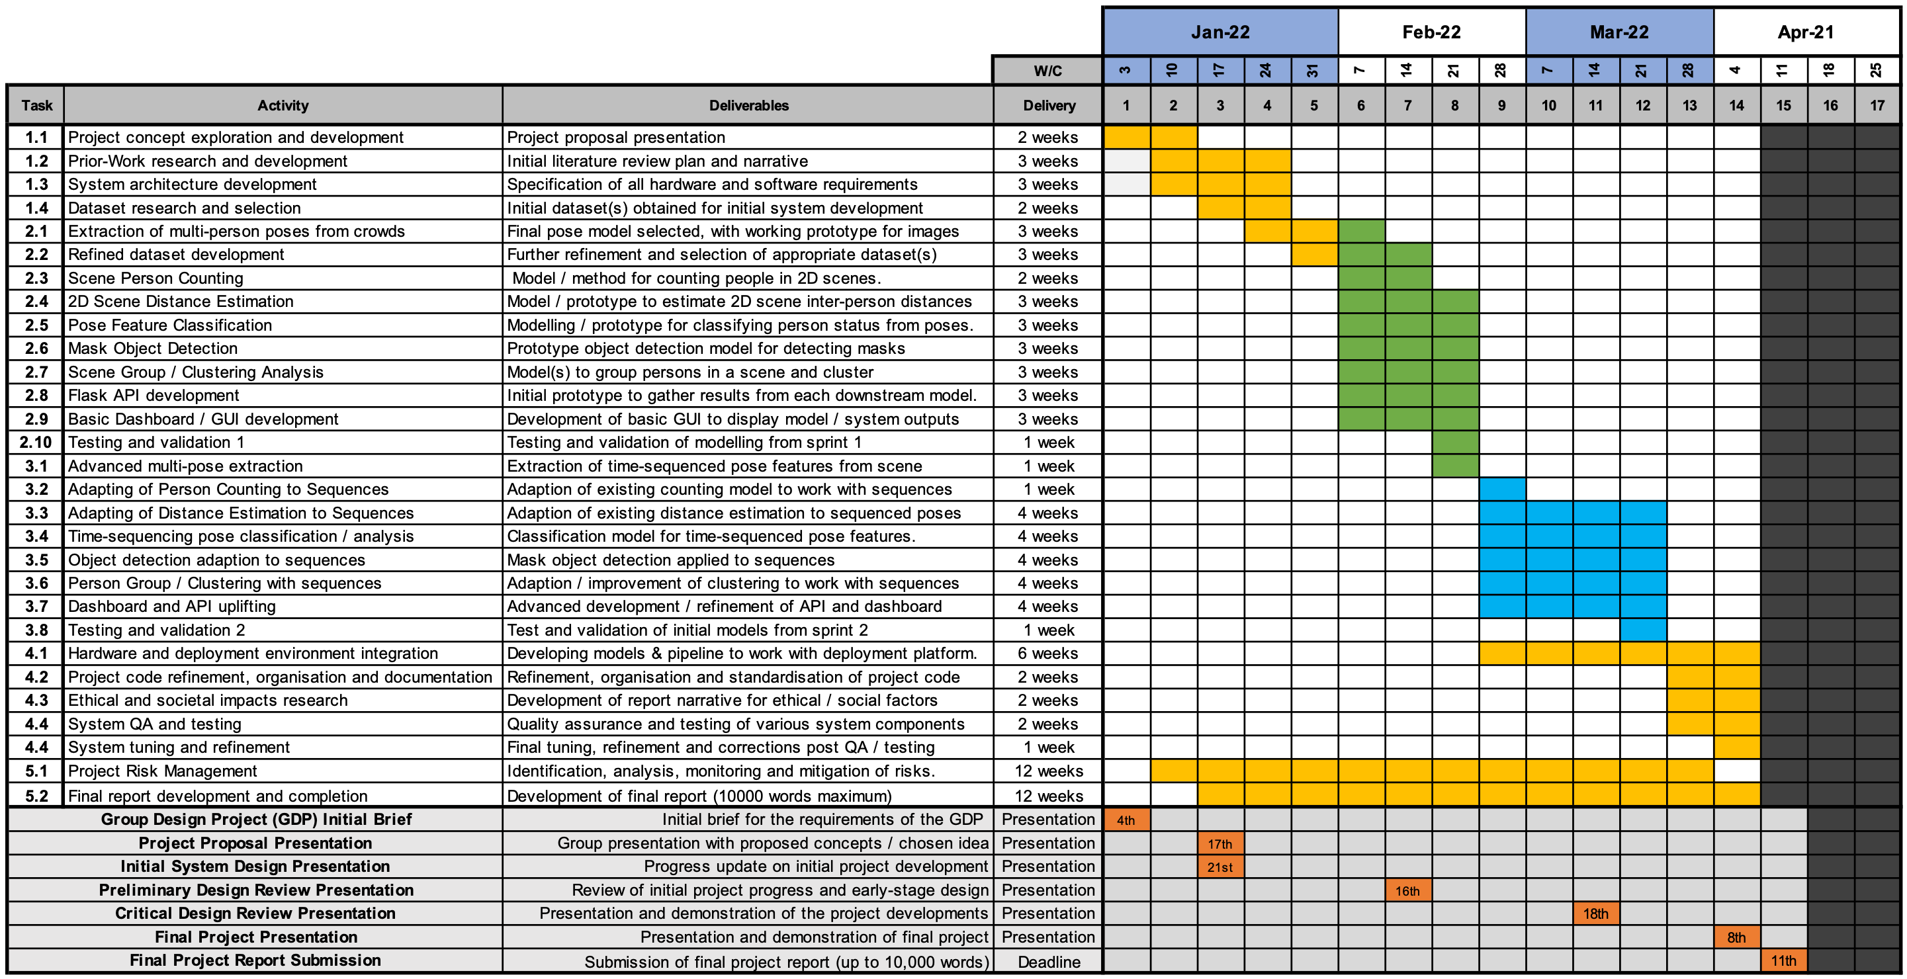

# Annex B: Project Risk Register

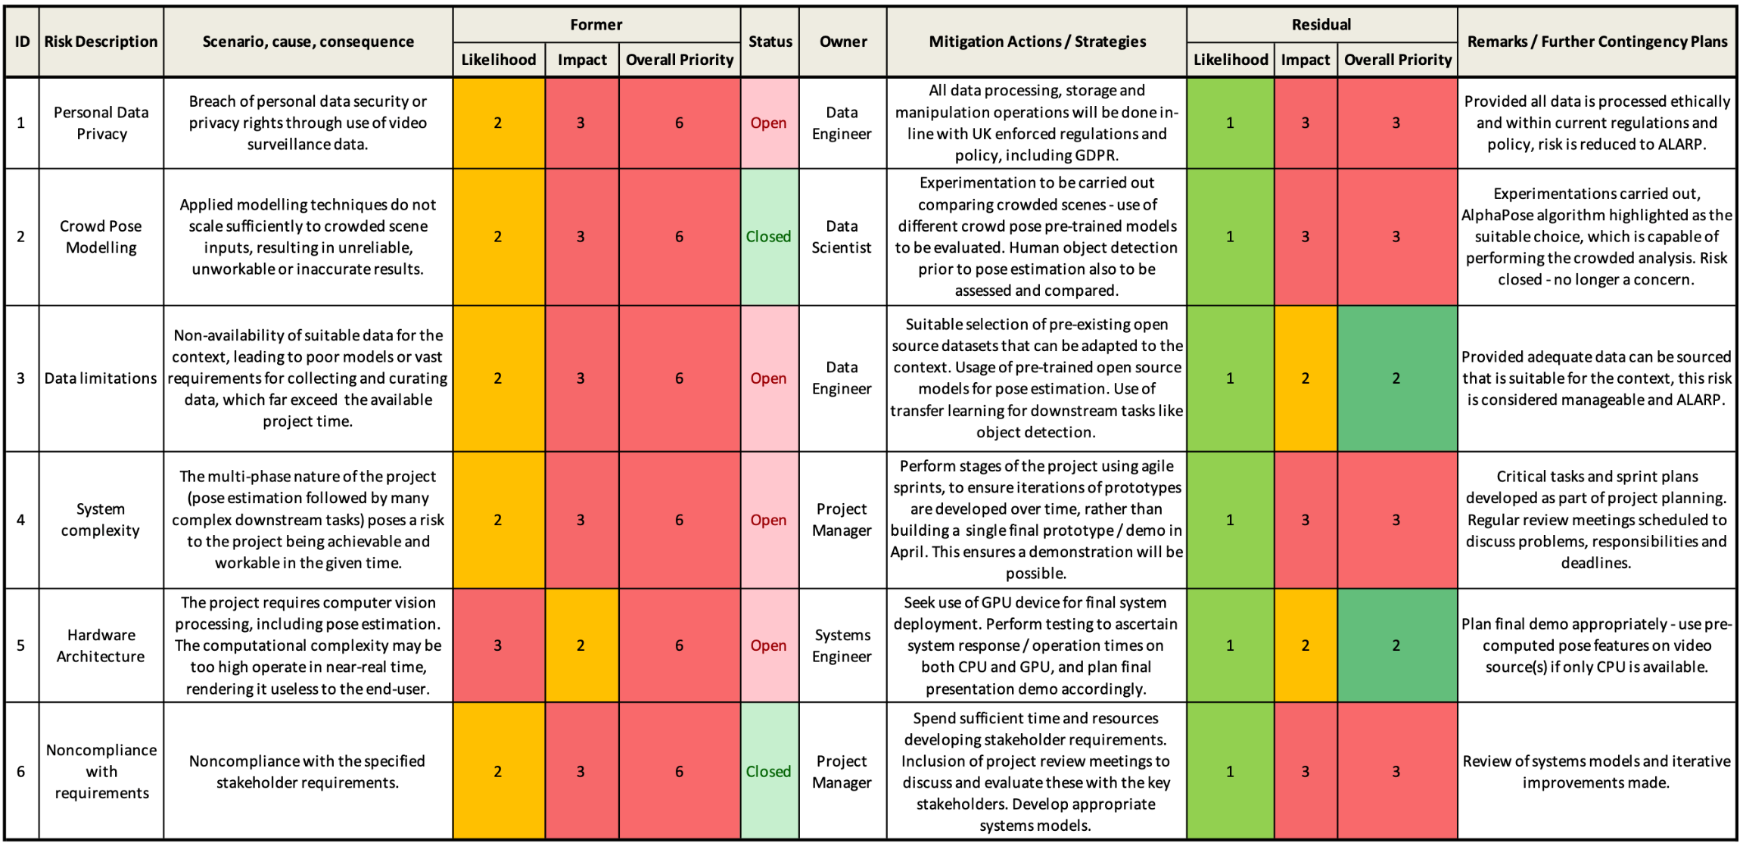

# Annex C: Integrated System Test Plan

